**PNEUMONIA DETECTION USING DEEP LEARNING**

**PROJECT REPORT**

**Submitted**

in partial fulfillment of the requirements

for the award of the degree of

**BACHELOR OF TECHNOLOGY**

in the faculty of

**COMPUTER SCIENCE & ENGINEERING**

by

**SHAIK SHER ALI** [R.NO. 21021A0505]

**BHUKYA NAVANEETHA**  [R.NO. 21021A0522]

**MATURI DIVYA SRI DURGA** [R.NO. 22025A0561]

Under the guidance of

**Dr. K.V.RAMANA**

**Professor**



**DEPARTMENT OF COMPUTER SCIENCE AND ENGINEERING**

**UNIVERSITY COLLEGE OF ENGINEERING KAKINADA**

**JAWAHARLAL NEHRU TECHNOLOGICAL UNIVERSITY**

**KAKINADA**, **KAKINADA - 533003, A.P, INDIA**

**[2021-2025]**

**DEPARTMENT OF COMPUTER SCIENCE AND ENGINEERING**

**UNIVERSITY COLLEGE OF ENGINEERING KAKINADA (A)**

**JAWAHARLAL NEHRU TECHNOLOGICAL UNIVERSITY**

**KAKINADA**, **KAKINADA - 533003, A.P, INDIA**

**[2021-2025]**



**DECLARATIO****N FROM THE STUDENTS**

We hereby declare that the project work described in this thesis, entitled “**PNEUMONIA DETECTION USING DEEP LEARNING”** which is being submitted by us in partial fulfillment of the requirements for the award of the degree of **BACHELOR OF TECHNOLOGY** (B.Tech.), in the faculty of Computer Science and Engineering Kakinada(Autonomous), **Jawaharlal Nehru Technological University Kakinada,** Kakinada – 533003, A.P., is the result of investigations carried out by us under the guidance of **Dr K.V. Ramana,** Professor, in the Department of **Computer Science and Engineering.**

The work is original and has not been submitted to any other University or Institute for the award of any degree or diploma.

**Place: Kakinada Signature:**

**Date:**

**SHAIK SHER ALI** [R.NO. 21021A0505]

**BHUKYA NAVANEETHA** [R.NO. 21021A0522]

**MATURI DIVYA SRI DURGA** [R.NO. 22025A0561]

**DEPARTMENT OF COMPUTER SCIENCE AND ENGINEERING**

**UNIVERSITY COLLEGE OF ENGINEERING KAKINADA**

**JAWAHARLAL NEHRU TECHNOLOGICAL UNIVERSITY**

**KAKINADA**, **KAKINADA - 533003, A.P, INDIA**

**[2021-2025]**



**CERTIFICATE FROM THE SUPERVISOR**

This is to certify that the project work entitled “**PNEUMONIA DETECTION USING DEEP LEARNING**” that is being submitted by **Shaik Sher Ali** bearing the roll number **21021A0505**, **Bhukya Navaneetha** bearing the roll number **21021A0522**, **Maturi Divya Sri Durga** bearing the roll number **22025A0561**, in partial fulfillment of the requirements for the award of the degree of **Bachelor of Technology(B.Tech.)** in the faculty of **Computer Science and Engineering** to the **UCEK(A), JNTUK**, Kakinada, Andhra Pradesh, India is a record of Bonafide project work carried out by them under my guidance and supervision during the academic year . It has been found satisfactory and hereby approved for submission.

**Signature of Supervisor**

**Dr K. V. Ramana**

Professor of CSE & Rector of JNTUK

UCEK(A)

JNTUK, Kakinada

**DEPARTMENT OF COMPUTER SCIENCE AND ENGINEERING**

**UNIVERSITY COLLEGE OF ENGINEERING KAKINADA (A)**

**JAWAHARLAL NEHRU TECHNOLOGICAL UNIVERSITY**

**KAKINADA**, **KAKINADA - 533003, A.P, INDIA**

**[2021-2025]**



**CERTIFICATE FROM THE HEAD OF THE DEPARTMENT**

This is to certify that the project work entitled “***PNEUMONIA DETECTION USING DEEP LEARNING***” that is being submitted by **Shaik Sher Ali** bearing the roll number **21021A0505**, **Bhukya Navaneetha** bearing the roll number **21021A0522**, **Maturi Divya Sri Durga** bearing the roll number **22025A0561**, in partial fulfillment of the requirements for the award of the degree of **Bachelor of Technology(B.Tech.)** in the faculty of **Computer Science and Engineering** to the **UCEK(A), JNTUK**, Kakinada, Andhra Pradesh, India is a record of bonafide project work carried out by them at our department.

**Signature of Head of the Department**

**Dr. N. Ramakrishnaiah**

Professor & HOD

Department of CSE

UCEK(A)

JNTUK, Kakinada

**ACKNOWLEDGEMENTS**

The successful completion of any task is not possible without proper suggestions, guidance, and environment. The combination of these three factors acts as a backbone to my “PNEUMONIA DETECTION USING DEEP LEARNING” project.I wish to thank first my supervisor Dr. K. V. Ramana Professor, Department of CSE for accepting and supporting us as a project team. I sincerely convey my gratefulness and heartfelt to my honorable and esteemed project guide for his supervision, guidance, encouragement, and counsel throughout my project. Without his invaluable advice and assistance, it would not have been possible for us to complete this project. His words of encouragement have often inspired me and improved my hopes for completing the project work.

I would like to thank Dr. N Ramakrishnaiah, Professor, and Head of the computer science and engineering department, UCEK, JNTUK for his fabulous support and useful remarks throughout the project.

I am thankful to Dr. N. Mohan Rao, Principal, University College of Engineering Kakinada (Autonomous), JNTUK for his support and enlightenment during the project. I am thankful to all the PRC members for their continuous suggestions. I thank all the teaching and non-teaching staff of the Department of Computer Science and Engineering for their support throughout my project work.

**SHAIK SHER ALI** [R.NO. 21021A0505]

**BHUKYA NAVANEETHA** [R.NO. 21021A0522]

**MATURI DIVYA SRI DURGA** [R.NO. 22025A0561]

**ABSTRACT**

Pneumonia is a severe lung infection that can be life-threatening if not diagnosed early. Traditional deep learning models often fail to consider background noise in X-ray images, reducing their diagnostic accuracy. This leads to misdiagnosis and limits the reliability of AI-based detection systems. Accurate pneumonia detection is crucial for early treatment, especially in resource-limited areas. Improving deep learning models by removing irrelevant image backgrounds can enhance classification accuracy. An explainable AI approach ensures transparency in medical diagnosis, building trust among healthcare professionals.

Current pneumonia detection models rely on CNN-based architectures that process entire X-ray images. Background noise affects feature extraction, leading to incorrect classifications. These models also lack explainability, making them less practical for real-world clinical use. The project introduces a deep learning approach that removes background noise from X-ray images for improved pneumonia detection. ResNet50 and VGG16 pretrained models are used for classification. A user-friendly front-end interface is developed for easy interaction and diagnosis visualization.

The system consists of data preprocessing, background removal, and deep learning-based classification. A web-based front end is created using Flask or React to allow doctors to upload and analyze X-ray images. The model results are visualized to highlight key areas of concern in the diagnosis.

The system can be expanded to detect different types of pneumonia and other lung diseases. Enhancements in background removal techniques and model optimization can improve accuracy. A real-time mobile or cloud-based application can be developed for faster and remote diagnosis.

**LIST OF ABBREVATIONS**

| **Abbreviation** | **Expansion** |
| --- | --- |
| AI | Artificial Intelligence |
| CNN | Convolutional Neural Network |
| VGG19 | Visual Geometry Group 19-layer model |
| Grad-CAM | Gradient-weighted Class Activation Mapping |
| API | Application Programming Interface |
| OpenCV | Open Source Computer Vision Library |
| CAM | Class Activation Mapping |
| ML | Machine Learning |
| DL | |  | | --- | | Deep Learning |  |  | | --- | |  | |
|  |  |
|  |  |
|  |  |
|  |  |
|  |  |
|  |  |

**TABLE OF CONTENTS**

**S.NO Topic Page No**

Acknowledgments v

Abstract vi

List of Abbreviations viii

**Chapter-1 Introduction 2**

* 1. Introduction to Pneumonia Detection 2
  2. Deep Learning 3

1.2.1 Why Deep Learning? 4

1.2.2 When to Apply Deep Learning? 4

* 1. Learning Paradigms 5

1.3.1 Supervised Learning 6

1.3.2 Unsupervised Learning 7

1.3.3 Reinforcement Learning 7

* 1. Workflow 7

1.4.1 Data Collection 7

1.4.2 Data Preprocessing 8

1.4.3 Model Selection 8

1.4.4 Model Training 9

1.4.5 Model evaluation 9

1.4.6 Hypermeter Tuning 9

1.4.7 Model Deployment 10

* 1. Problem Statement 10
  2. Existing System 11

1.6.1 Description 11

1.6.2 Drawbacks of existing system 12

**Chapter-2 Literature Survey 14**

**Chapter-3 Requirements of Project 17**

3.1 Hardware Requirements 17

3.2 Software Requirements 17

3.2.1 Python 17

3.2.2 TensorFlow 18

3.2.3 Keras 18

3.2.4 OpenCV 19

3.2.5 Matplotlib and Seaborn 20

3.2.6 Flask 20

3.2.7 Other Libraries (Optional) 21

3.2.8 Version Control (Git) 21

**Chapter-4 System Analysis 23**

4.1 Proposed System 23

4.1.1 Description 23

4.1.2 Advantages 25

**Chapter-5 Architecture of the proposed system 28**

5.1 Transfer Learning 28

5.1.1 Key Concepts of Transfer Learning 28

5.1.2 Steps Involved in Transfer Learning 29

5.1.3 Benefits of Transfer Learning 30

in Pneumonia Detection

5.2 VGG19 Model 31

5.2.1 VGG19 31

5.2.2 Model Architecture 32

**Chapter-6 System Implementation 38**

6.1 Data Preprocessing 38

6.1.1 Data 38

6.1.2 Preparing the Data for Model Training 38

6.2 Model 39

6.2.1 Transfer Learning with VGG19 39

6.2.2 Model Layers 40

6.2.3 Activation Function – ReLU 40

6.2.4 Loss Function – Binary Cross Entropy 41

**Chapter-7 Dataset Collection 43**

7.1 Dataset Collection 43

7.2 Dataset Splitting 44

7.3 Image Preprocessing 44

7.4 Model Preparation using VGG19 45

7.5 Model Compilation 47

7.6 Model Training 48

7.7 Model Evaluation 49

**Chapter-8 Source Code 53**

8.1 Dataset Loading and Visualization 53

8.2 Data Preprocessing and Augmentation 54

8.3 Model Compilation and Training 56

8.4 Model Evaluation and Performance Metrics 57

8.5 Final Testing Results 59

**Chapter-9 Results and Performance Analysis 61**

9.1 Existing System 61

9.2 Proposed System 62

9.2.1 Accuracy 62

9.2.2 Precision 62

9.2.3 Recall 63

9.2.4 F1-score 63

9.3 Outputs of Web Interface 64

9.3.1 Home Page (User Interface) 64

9.3.2 Chest X-ray Upload Interface 64

9.3.3 Preview of Uploaded Chest X-ray Image 65

9.3.4 Pneumonia Detection Result Display 65

9.3 5 Enhanced Result Visualization with 66

Grad-Cam Heatmap

**Chapter-10 Conclusion and Future Scope 68**

10.1 Conclusion 68

10.2 Future Scope 69

**Chapter-11 References 71**

**CHAPTER 1**

**INTRODUCTION**

**CHAPTER – 1**

**INTRODUCTION**

**1 Introduction**

* 1. **Introduction to Pneumonia Detection**

Pneumonia is a lung infection that causes inflammation of the air sacs (alveoli) in one or both lungs. These air sacs may fill with fluid, pus, or cellular debris, leading to symptoms such as cough with phlegm or pus, fever, chills, and difficulty breathing. Pneumonia can range in seriousness from mild to life-threatening and is especially dangerous for vulnerable groups such as young children, elderly individuals, and people with chronic illnesses or weakened immune systems.

Globally, pneumonia remains a significant public health concern. According to the World Health Organization (WHO), pneumonia accounts for approximately 15% of all deaths of children under 5 years old, making it one of the leading causes of child mortality. Despite being treatable and preventable in many cases, the disease continues to claim millions of lives annually, highlighting the urgent need for early diagnosis and effective management.

Diagnosis typically involves clinical evaluation, chest X-rays, and laboratory tests. Chest radiography is crucial as it helps in visualizing lung infiltrates and confirming the presence of infection. However, in many areas, there is a shortage of skilled radiologists, leading to delays or inaccuracies in diagnosis. This has created a demand for automated, AI-driven solutions that can assist or even independently detect pneumonia in medical images.

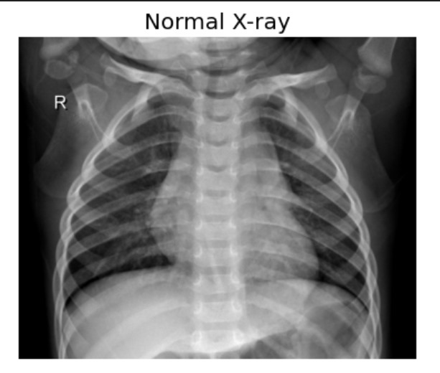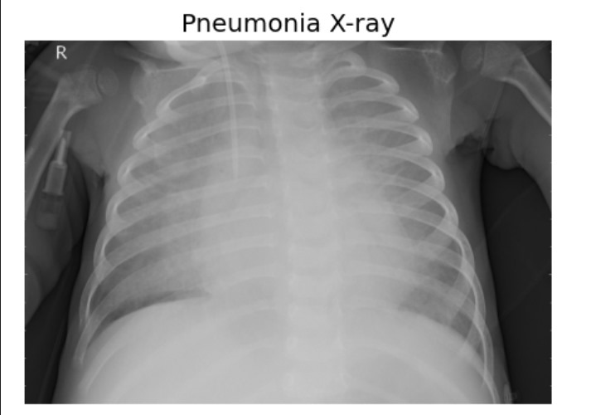

Fig 1.1 Difference in x-ray images in Normal and abnormal cases

The use of machine learning and deep learning in medical diagnostics has shown promising results in recent years. In particular, Convolutional Neural Networks (CNNs), a class of deep learning models highly effective in image classification tasks, have been applied to the detection of pneumonia from chest X-rays. Such models aim to provide faster, reliable, and accessible diagnostic support, especially in under-resourced healthcare settings.

In this project, the goal is to develop a deep learning-based pneumonia detection system that can classify chest X-ray images as either "Pneumonia" or "Normal." By leveraging modern AI techniques, the project aspires to contribute to early diagnosis efforts, reduce dependency on radiological expertise, and support global health initiatives to combat pneumonia.

* 1. **Deep Learning**

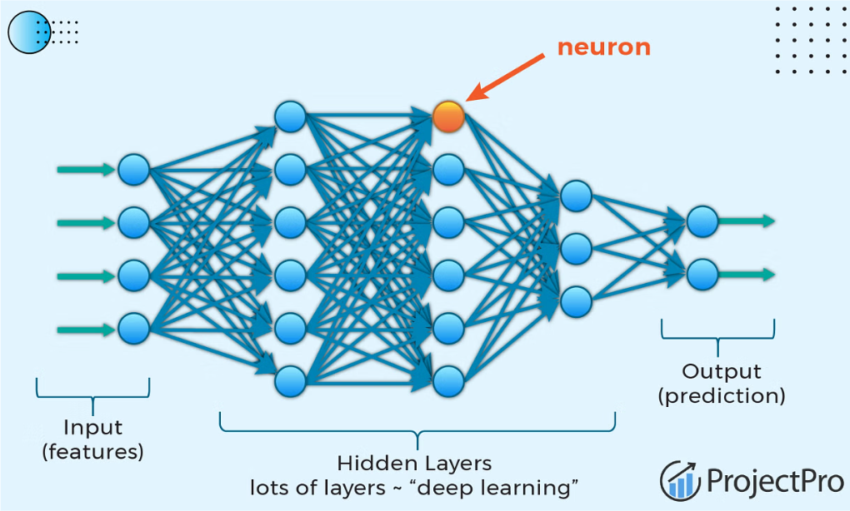 Deep learning is a subset of machine learning and artificial intelligence (AI) that mimics the way the human brain processes information. It involves the use of artificial neural networks with many layers (hence the term "deep") to automatically learn features and patterns from large amounts of data. Deep learning has revolutionized many fields such as computer vision, natural language processing, and medical diagnostics due to its ability to achieve high performance without the need for manual feature extraction.

Fig 1.2 Deep learning

In the context of image classification tasks like pneumonia detection from chest X-rays, deep learning models, especially Convolutional Neural Networks (CNNs), are highly effective. CNNs are specialized neural networks d esigned to automatically and efficiently process visual data.

They can learn hierarchical features — from simple edges and shapes in early layers to complex lung patterns and abnormalities in deeper layers — without requiring explicit programming.

* + 1. **Why Deep Learning?**

**Automated Feature Extraction**: Traditional machine learning approaches often rely on handcrafted features, which require domain expertise and may miss subtle indicators. Deep learning automatically learns the most relevant features directly from the X-ray images.

**High Accuracy**: Deep learning models, particularly CNNs, have achieved state-of-the-art performance in medical image analysis, often matching or even exceeding human expert accuracy in specific tasks.

**Scalability**: Once trained, a deep learning model can quickly process and classify thousands of X-ray images, making it highly scalable for deployment in hospitals and clinics.

**Consistency**: Unlike human analysis, deep learning models are not affected by fatigue, subjectivity, or variation in interpretation, leading to more consistent diagnostic outcomes.

**Speed**: Deep learning models can deliver near-instant results after the initial training, allowing for faster decision-making and timely treatment of patients.

**Support for Resource-Limited Settings**: In areas where skilled radiologists are scarce, an AI-powered system can assist healthcare workers by providing a second opinion or even by acting as a primary diagnostic tool.

**1.2.2 When to Apply Deep Learning?**

Deep learning is a powerful tool, but it is not always the best choice for every problem. It is most effective in situations where the problem is complex and large amounts of data are available. The following are typical conditions when applying deep learning is appropriate:

**1. Availability of Large Datasets**

Deep learning models, particularly deep neural networks, require a significant amount of labeled data to learn effectively. If a project involves thousands or millions of examples — such as chest X-ray images for pneumonia detection — deep learning is a suitable choice.

**2. Complex Pattern Recognition**

When the task involves recognizing intricate patterns or relationships in the data (such as identifying subtle differences in medical images), deep learning models outperform traditional machine learning methods that rely on manual feature engineering.

**3. High Accuracy Requirements**

In fields where precision is critical, like medical diagnostics, autonomous driving, or financial forecasting, deep learning models often deliver higher accuracy compared to simpler models, provided they are properly trained and validated.

**4. Automation of Feature Extraction**

If manually designing features is difficult or impractical, deep learning can automatically learn the best features from raw data. This makes it highly valuable for complex tasks like speech recognition, natural language understanding, and image classification.

**5. End-to-End Learning**

When the goal is to build an end-to-end system — where the model directly maps input data (e.g., an X-ray image) to an output (e.g., "Pneumonia" or "Normal") without the need for intermediate steps — deep learning models are very effective.

**6. Handling Unstructured Data**

Deep learning excels at processing unstructured data such as images, videos, audio, and text. In this project, since the input consists of medical images (chest X-rays), deep learning is the natural choice.

**1.3 Learning Paradigms**

1.Supervised Learning

2.Unsupervised Learning

3.Reinforcement Learning

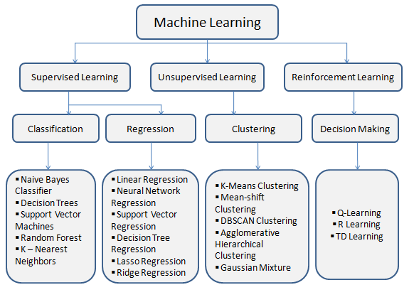

Fig 1.3: Learning Paradigms in Machine Learning

**1.3.1 Supervised Learning:**

Supervised learning is a foundational concept in machine learning, particularly in the context of classification and regression tasks. In supervised learning, the algorithm is trained on a labeled dataset, where each input data point is associated with a corresponding target or output label. The goal is to Supervised learning algorithms can be broadly categorized into two main types: parametric and non parametric. Parametric models, such as linear regression and logistic regression, make assumptions about the underlying distribution of the data and learn a set of parameters that define the relationship between the input features and the output labels. Supervised learning is effective when there is a large amount of labeled data available for training the model. It is widely used in various applications such as image recognition, natural language processing, 6 and speech recognition. Supervised learning has widespread applications across various domains, including healthcare, finance, natural language processing, computer vision, and more. Non-parametric models, such as decision trees, k-nearest neighbors (KNN), and support vector machines (SVM), do not make explicit assumptions about the data distribution and instead rely on flexible representations to capture complex patterns in the data.

**1.3.2 Unsupervised Learning**:

Unsupervised learning is a branch of machine learning where the algorithm learns from unlabeled data without explicit supervision. Unlike supervised learning, where the model is trained on input-output pairs, unsupervised learning aims to identify patterns, relationships, or structures within the data without predefined labels. One common task in unsupervised learning is clustering, where the algorithm groups similar data points together based on their intrinsic characteristics. Unsupervised learning has numerous applications across various domains, including anomaly detection, customer segmentation, recommendation systems, and data preprocessing. In anomaly detection, unsupervised learning algorithms can identify unusual patterns or outliers in the data that may indicate fraudulent behavior, equipment failure, or other anomalies. Customer segmentation involves dividing customers into distinct groups based on their purchasing behavior, demographics, or preferences, allowing businesses to tailor their marketing strategies and product offerings to different segments.

**1.3.3 Reinforcement Learning**:

Reinforcement learning (RL) is a branch of machine learning concerned with how software agents ought to take actions in an environment to maximize some notion of cumulative reward. Unlike supervised learning, where models are trained on labeled data, or unsupervised learning, which deals with discovering hidden patterns in unlabeled data, reinforcement learning focuses on learning optimal behavior by interacting with an environment. At the heart of reinforcement learning is the concept of an agent, which learns to navigate its environment through a process of trial and error. The key idea behind reinforcement learning is to learn from the consequences of actions taken within an environment. Reinforcement learning has found applications in a wide range of domains, including robotics, gaming, finance, healthcare, and autonomous systems. In robotics, reinforcement learning algorithms are used to train robots to perform complex tasks, such as grasping objects or navigating obstacles, by interacting with their environment.

**1.4 Workflow**

**1.4.1 Data Collection**

The initial step in any machine learning project is to **collect relevant data**. For pneumonia detection, a large and diverse dataset of chest X-ray images is essential for training the model. The most commonly used datasets include the **Chest X-Ray Images (Pneumonia)** dataset from Kaggle, which contains over 5,000 labeled X-ray images of patients diagnosed with pneumonia and healthy individuals. These images are typically categorized into "Normal" and "Pneumonia" classes. The quality and quantity of the dataset directly influence the accuracy and performance of the model, making this step critical. In some cases, data augmentation techniques can be used to artificially enlarge the dataset and reduce the risk of overfitting.

**1.4.2 Data Preprocessing**

Data preprocessing is crucial to ensure that the raw data is in the correct format and ready for model training. This step includes several tasks:

* **Resizing images**: X-ray images come in different sizes, and they must be resized to a uniform size, such as 224x224 pixels, to ensure that the neural network can process them.
* **Normalization**: Image pixel values typically range from 0 to 255. Normalization scales the pixel values between 0 and 1 or -1 and 1, which helps the neural network converge more quickly during training.
* **Data augmentation:** To create more variety in the training set and reduce overfitting, data augmentation techniques like random rotations, flips, zooms, and shifts are applied. This enables the model to learn more generalized features rather than memorizing specific patterns.
* **Splitting the dataset**: The dataset is split into training, validation, and test sets. The training set is used to train the model, the validation set helps in tuning hyperparameters, and the test set is used to evaluate the final model's performance.

**1.4.3 Model Selection**

The next step is to select a suitable model architecture. For medical image classification, Convolutional Neural Networks (CNNs) are the most commonly used models due to their ability to learn spatial hierarchies of features (edges, textures, shapes). CNNs use convolutional layers that automatically extract features from images, reducing the need for manual feature engineering.

Transfer Learning is often applied in pneumonia detection, especially when the dataset is not large enough to train a model from scratch. Pre-trained models like VGG19, ResNet50, InceptionV3, or MobileNet are fine-tuned for the pneumonia detection task. These models have been trained on large-scale datasets like ImageNet and have learned a broad set of features that can be transferred to the pneumonia detection task. Fine-tuning the pre-trained model saves time and improves performance, especially with limited training data.

**1.4.4 Model Training**

During model training, the selected CNN model is fed with the processed images. The model iteratively adjusts its weights through backpropagation, minimizing the loss function (commonly binary cross-entropy for binary classification tasks). The model learns from the training data, identifying patterns associated with pneumonia, such as fluid in the lungs or lung consolidation.

Optimization algorithms like Adam or Stochastic Gradient Descent (SGD) are used to minimize the loss function. The training process is performed over multiple epochs, where the model is exposed to the data repeatedly. To prevent overfitting, regularization techniques like dropout or early stopping are applied, which ensure that the model generalizes well to unseen data. Batch processing is also used to speed up training, by processing multiple images at once.

**1.4.5 Model evaluation**

Once the model is trained, it must be evaluated on a **test dataset** to assess its performance. Key evaluation metrics include:

* **Accuracy**: The percentage of correct predictions made by the model.
* **Precision and Recall**: These metrics are critical when dealing with imbalanced datasets. Precision measures the accuracy of positive predictions, while recall measures the model’s ability to detect all positive instances (pneumonia cases).
* **F1-Score**: The harmonic mean of precision and recall, which provides a balanced evaluation metric.
* **Confusion Matrix**: A visual representation of true positives, false positives, true negatives, and false negatives, which helps in understanding the types of errors the model is making.
* **ROC Curve and AUC**: The Receiver Operating Characteristic (ROC) curve plots the true positive rate against the false positive rate, and the Area Under the Curve (AUC) score indicates the model's ability to discriminate between classes. A higher AUC indicates better model performance.

**1.4.6 Hypermeter Tuning**

Hyperparameter tuning is the process of finding the best configuration of hyperparameters for the model. Hyperparameters are parameters that are set before the model training and are not learned from the data. Common hyperparameters in CNNs include the learning rate, batch size, number of filters in convolution layers, and number of layers.

Grid search and random search are popular methods for hyperparameter tuning. In grid search, all possible combinations of a predefined set of hyperparameters are tried, while random search randomly samples from the possible hyperparameters, which can sometimes be more efficient. More advanced techniques like Bayesian optimization or genetic algorithms may also be used for a more targeted search.

Proper hyperparameter tuning can significantly improve the model's performance, leading to a better generalization ability on unseen data.

**1.4.7. Model Deployment**

After the model has been trained, evaluated, and tuned, it is ready for deployment. The deployment phase involves making the trained model available for real-time predictions. This typically involves saving the model's weights and architecture in a suitable format (e.g., .h5, .pkl).

A web application is built using frameworks like Flask or Django, which provides an interface for users to upload chest X-ray images. Once the image is uploaded, the application sends it to the model, which processes the image and returns a prediction, such as "Normal" or "Pneumonia."

For large-scale deployment, cloud services like AWS, Google Cloud, or Microsoft Azure can be used to host the model, providing scalability, security, and ease of access. The deployment process ensures that healthcare professionals or anyone with access to the system can use the pneumonia detection model to assist with diagnoses, ultimately improving patient care and outcomes.

**1.5 Problem Statement**

Project aims to develop a deep learning-based model for Automated Pneumonia detection from chest X-ray images. By leveraging Convolutional Neural Networks (CNNs), the model will classify images as either Normal or Pneumonia, improving diagnostic accuracy and efficiency while reducing human error.

**1.6 Existing System**

**1.6.1 Description**

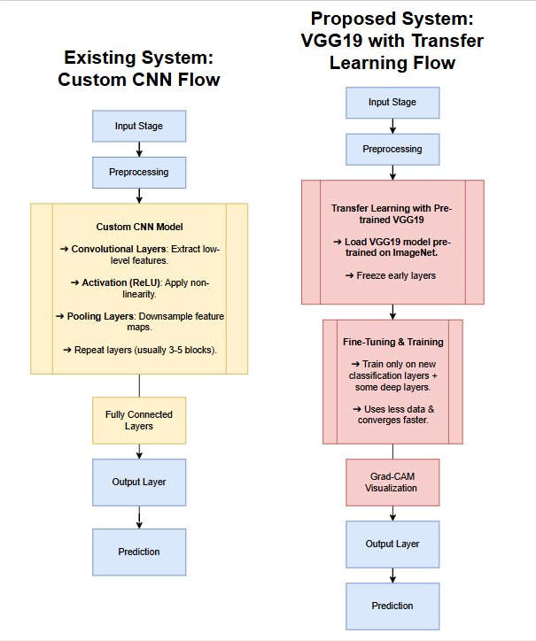In the current approach to pneumonia detection using deep learning, custom-designed Convolutional Neural Networks (CNNs) are commonly employed to classify chest X-ray images. These CNNs automatically learn spatial features from the images using layers of convolutional filters, ReLU activations, pooling operations, and fully connected layers. The early layers detect basic visual features like edges or textures, while the deeper layers extract more abstract patterns relevant to identifying pneumonia. A typical architecture might include 2–3 convolutional layers for feature extraction, followed by a few fully connected layers and an output layer (sigmoid or softmax) for prediction.

Fig 1.4: Existing System: Custom CNN Flow

Although custom CNNs offer flexibility and control over the network design, they often fall short in complex domains like medical imaging. Diagnosing pneumonia from X-rays requires the detection of subtle visual cues such as fine opacities, irregular lung textures, or faint consolidations — features that simpler CNNs may miss. Furthermore, their effectiveness heavily relies on large, well-annotated medical datasets. However, collecting such datasets is challenging due to strict privacy regulations, the high cost and time required for expert radiologist annotations, and limited representation of diverse patient demographics. Since these models are trained from scratch, they require extensive computational resources and training time. Without sufficient abelled data, custom CNNs are prone to overfitting or underfitting, which limits their ability to generalize to new, unseen X-ray images.

**1.6.2 Drawbacks of the Existing System**

The existing custom CNN-based pneumonia detection systems face several critical drawbacks that hinder their practical applicability and robustness in clinical environments:

1. **Limited Feature Learning Capability:**

Custom CNNs often struggle to detect subtle and complex features in medical images, such as faint opacities or irregular lung textures, leading to reduced diagnostic accuracy.

1. **High Risk of Overfitting:**

Due to small and imbalanced datasets in medical imaging, custom CNNs may memorize training data rather than learn generalizable features, resulting in poor performance on unseen X-rays.

1. **Long Training Time and High Computational Load**:

Training CNNs from scratch requires substantial time and computing power, which can be a major limitation in resource-constrained environments.

1. **Poor Generalization to Diverse Data**:

Custom CNNs trained on limited or homogenous datasets often fail to perform consistently across varied patient demographics, imaging conditions, and clinical settings.

**CHAPTER 2**

**LITERATURE SURVEY**

**CHAPTER – 2**

**LITERATURE SURVEY**

**Literature Survey:**

2.1 Vandecia Fernandes et al. [1] Proposed, developing a reliable version to detect COVID-19 from X-ray images offers a number of challenges. First of all, there are a limited number of images to be had. The pandemic has simplest been spreading for a few months and now not many datasets have been gathered and shared for the benefit of researchers. Secondly, there may be an urgent need for scientific researchers to develop a wise device for the fast detection and deep expertise of infectious diseases from chest X-ray pictures, which could illustrate the damage to the human body. After investigating the presently available technology and the demanding situations we are going through, it's concluded that a transfer learning of technique is possible and realistic for this study's problem. Our research technique is to train deep learning models at the available images of pneumonia, and contamination in a single or both lungs which may be resulting from microorganisms, viruses, or fungi. The infection causes inflammation inside the air sacs in the lungs, which might be known as alveoli. The alveoli fill with fluid or pus, making it hard to respire the system takes benefit of transfer learning on properly-studied of deep learning to know the type of virus and validates the models on a big quantity of data sets, and finally transfers the models and insights learned in training and validation to a brand new data set in a comparable area, which, in this have a look at, is a new infectious fast-growing sickness, COVID-19 or coronavirus. The proposed technique solves the tough problem in deep learning, this is, how to construct a dependable model primarily based on a scarce information set, which is not well studied and there are unknown features inside the statistics set.

2.2 Hongen Lu et al.[2]Deep CNNs indeed acquire higher performance with the use of a huge dataset as compared to a smaller one. Granting there is an enormous range of infected COVID-19 patients globally, however, the variety of publicly available chest X-ray photos online is insignificant and dispersed. For this reason, the authors of this work have defined a reasonably huge dataset of COVID-19 infected chest X-ray images even though normal and pneumonia photographs are right away on hand publicly and applied in this study.

2.3 Sammy V. Militante et al.[3] Proposed,The observations employ flexible and efficient approaches of deep learning by making use of six models of CNN in predicting and spotting whether the patient is unaffected or affected by the disease employing a chest X-ray picture. Google Net, Le Net, VGG-16, Alex Net, Strident, and ResNet-50 models with a dataset of 28,000 images and using a 224x224 decision with 32 and sixty-four batch sizes are implemented to verify the performance of every version being educated. The study likewise implements Adam as an optimizer that continues an adjusted 1e-four learning rate and an epoch of 500 hired to all the models. Both Google Net and Le Net acquired a ninety-eight% price, VGG Net -sixteen earned an accuracy charge of ninety-seven%, Alex Net and Stride Net model acquired a ninety-six% whilst the ResNet-50 version acquired 80% throughout the training of models. Google Net and Le Net fashions performed the best accuracy rate for overall performance training. The six models identified had been capable of hitting upon and are expecting pneumonia sickness including a wholesome chest X-ray.

2.4 Nanette V. Dionisio et al.[4]Proposed, classify the three varieties of X-rays, image writer used the ensemble method at some stage in prediction, each picture is surpassed through the type layer where they checked whether an image is COVID-19, pneumonia, or ordinary.

|  |  |  |  |
| --- | --- | --- | --- |
| Sr.  no | Paper Allocation | Author | Methods |
| 1 | Bayesian convolutional  neural network estimation for paediatric pneumonia detection and diagnosis | Vandecia Fernandes et al. | Bayesian convolutional neural network |
| 2 | Transfer Learning from Pneumonia to COVID-19 | Hongen Lu et al. | Transfer Learning |
| 3 | Pneumonia and COVID-19 Detection using Convolutional Neural Networks | Sammy V. Militante et al. | Convolutional Neural Networks |
| 4 | Pneumonia Detection through Adaptive Deep Learning Models of Convolutional Neural Networks | Nanette V. Dionisio et al. | Deep Learning Models |

**CHAPTER 3**

**REQUIREMENTS OF PROJECT**

**CHAPTER – 3**

**REQUIREMENTS OF PROJECT**

**3.1 Hardware Requirements**

To effectively train, test, and deploy the Pneumonia Detection System, the following hardware specifications are recommended:

* **Processor (CPU):** A minimum of Intel Core i5 (or similar one) is required. However, for faster processing and smoother performance, Intel Core i7 above is recommended.
* **Memory (RAM):** At least 8 GB of RAM is necessary for running the model and application. For efficient handling of large datasets and faster processing,
* **Storage:** A minimum of 256 GB of storage space (HDD or SSD) is required. It is advisable to use SSD for quicker data access and file loading times.
* **Graphics Card (GPU):** While a GPU is optional for inference, it is highly recommended for training deep learning models. An NVIDIA GTX 1050 with 4 GB VRAM is the minimum, whereas an NVIDIA RTX 2060/3060 or higher with 6-8 GB VRAM is preferred for better performance.
* **Display:** A minimum HD resolution of 1366x768 is required, though a Full HD (1920x1080) display is recommended for clear visualization of heatmaps and results.
* **Internet Connection:** A stable internet connection is required for downloading datasets, libraries, and for hosting web interface online.

**3.2 Software Requirements**

In this section, we list and describe the essential software tools and libraries needed to successfully implement and deploy the **Pneumonia Detection Using Deep Learning** system. These libraries are integral for building, training, and serving the machine learning model, as well as for the front-end and back-end development.

**3.2.1 Python**

* **Version:** Python 3.7 or higher
* **Description:**  
  Python is the primary programming language used for the entire **Pneumonia Detection** system. Python’s simple syntax and extensive support for scientific computing and machine learning make it the ideal choice for this project. The language facilitates smooth integration with various deep learning frameworks and libraries.
* **Why Python?**

Python provides a high-level interface to work with deep learning libraries like **TensorFlow** and **Keras**, making the development process quicker and more intuitive.

It supports a wide range of tools for data analysis, processing, and visualization, such as **Pandas** and **NumPy**, which are critical for preprocessing the dataset.

Python is compatible with **Jupyter Notebooks** for easy experimentation and iterative development

* **Environment Management:**  
  It is recommended to use a virtual environment (via venv or conda) to isolate the project dependencies, preventing conflicts with other Python projects.
* **Installation Command:** pip install python

**3.2.2 TensorFlow**

* **Version:** 2.x or higher
* **Description:**  
  **TensorFlow** is an open-source deep learning framework developed by Google, designed for building and deploying machine learning models at scale. TensorFlow is highly optimized for both training and inference, making it the go-to framework for deep learning projects like this one.
* **Why TensorFlow?**

TensorFlow supports both **CPU** and **GPU** computations, accelerating training times, especially on large datasets like medical images used in pneumonia detection.

The framework is flexible, allowing for the construction of custom neural networks and layers, which is crucial for building the **VGG19-based deep learning model** used in this project.

TensorFlow also provides the **TensorFlow Lite** API, which allows for the deployment of models on mobile and embedded devices (which could be a future scope for this project).

**Key Features:**

**Keras Integration:** TensorFlow includes **Keras** as its high-level API, simplifying the process of building and training deep learning models.

**TensorFlow Hub**: Pretrained models and reusable model components for faster development.

**TensorFlow Serving:** A system for serving machine learning models in production environments.

* **Installation Command:** pip install tensorflow

**3.2.3 Keras**

* **Version:** 2.4.3 or higher
* **Description:**  
  **Keras** is a high-level neural networks API that runs on top of TensorFlow. It provides an easy-to-use interface for building deep learning models with minimal code. Keras allows the definition of models using layers, optimizers, and activation functions in a more concise and readable manner.
* **Why Keras?**

Keras simplifies model creation, allowing you to define complex models quickly, making it suitable for rapid prototyping and experimentation.

It supports a variety of **pre-trained models** and **transfer learning**, which is especially useful for medical image analysis.

Keras provides the Model.fit() API, which streamlines training the deep learning models with less boilerplate code.

* **Key Features:**

**Layer-wise Model Building:** Define and stack layers easily.

**TensorFlow Backend:** Keras uses TensorFlow as its backend, leveraging TensorFlow’s optimization features.

**Built-in Support for Model Evaluation and Testing:** Methods like .evaluate() and .predict() help evaluate model accuracy, loss, and predict new data.

* **Installation Command:** pip install keras

**3.2.4 OpenCV**

* **Version:** 4.5 or higher
* **Description:**  
  **OpenCV** (Open Source Computer Vision Library) is an open-source library used for real-time computer vision. It provides functionalities for image and video processing, which are critical in the **preprocessing** stage of machine learning.
* **Why OpenCV?**

**Image Preprocessing:** OpenCV allows you to resize, crop, rotate, and convert images into the required format for model input. This is essential when working with medical images that might not be in a standard format.

**Augmentation:** OpenCV is used for augmenting the dataset with transformations like flipping, rotating, or adding noise, helping improve model generalization.

**Heatmap Generation:** OpenCV is used to visualize model outputs, like **Grad-CAM** heatmaps, which highlight areas of the image the model focuses on when making predictions.

* **Key Features:**

**Image Transformation:** Functions for color space conversion, image resizing, and geometric transformations.

**Face Detection and Object Recognition:** For more advanced applications beyond pneumonia detection.

**Video Analysis:** OpenCV can be used for real-time video analysis, which can be useful if the project is extended to real-time diagnostics.

* **Installation Command:** pip install opencv-python

**3.2.5 Matplotlib and Seaborn**

* **Version:**
  + **Matplotlib:** 3.3 or higher
  + **Seaborn:** 0.11 or higher
* **Description:**  
  Both **Matplotlib** and **Seaborn** are powerful Python libraries used for data visualization. They help present the results of the model training process, as well as visual insights into the dataset, aiding in debugging and model evaluation.

**Matplotlib** provides low-level control over plots, allowing for custom visualizations like loss curves, accuracy curves, and confusion matrices.

**Seaborn** is a high-level wrapper built on Matplotlib, making it easier to create beautiful statistical plots like heatmaps and pair plots.

* **Why Use Matplotlib and Seaborn?**

**Model Evaluation:** These libraries allow for visualizing the training progress, which helps in identifying overfitting, underfitting, and other issues with the model.

**Visualization of Feature Importance:** Seaborn’s heatmaps can visualize important regions in the input image (via Grad-CAM) or important features that the model uses for decision-making.

**Ease of Use:** Seaborn provides concise syntax for common plots, while Matplotlib provides flexibility for complex visualizations.

* **Installation Command:** pip install matplotlib seaborn

**3.2.6 Flask**

* **Version:** 2.x or higher
* **Description:**  
  **Flask** is a micro web framework for Python, designed for building lightweight web applications. Flask is ideal for small projects like this one, where you need to serve the trained deep learning model and integrate it with a user-facing web interface.
* **Why Flask?**

**Simplicity:** Flask allows for quick development and deployment of web applications. It’s a lightweight framework that gives the developer control over the project structure.

**Integration with ML Models:** Flask is often used to build REST APIs that interact with machine learning models. It can load the trained model and process user input to give real-time predictions.

**Templating:** Flask supports HTML templating with **Jinja2**, which is used to render the web interface for the pneumonia detection results.

* **Key Features:**

**Routing and Request Handling:** Flask simplifies defining URLs and handling HTTP requests, making it easy to expose the model prediction endpoint.

**Template Rendering:** Use **Jinja2** templates to dynamically generate HTML pages based on the model output, such as displaying prediction results, heatmaps, etc.

**Extension Support:** Flask can be extended with additional libraries for database integration, form handling, etc.

* **Installation Command:** pip install flask

**3.2.7 Other Libraries (Optional)**

* **Pandas** (for data handling and manipulation):

pip install pandas

* **NumPy** (for numerical operations):

pip install numpy

* **Jupyter Notebook** (for interactive development and testing):

pip install notebook

**3.2.8 Version Control (Git)**

* **Version:** Git 2.x or higher
* **Description:**  
  Git is a version control system that is used to manage changes in the project's source code and track the history of code modifications. Using platforms like GitHub or GitLab is crucial for collaborating with teams and deploying models in the future.

It ensures a proper workflow in handling different versions of the code and collaborating with other developers.

Using a Git workflow like **GitFlow** can further organize feature development, testing, and releases.

**CHAPTER 4**

**SYSTEM DESIGN AND ANALYSIS**

**CHAPTER – 4**

**SYSTEM DESIGN AND ANALYSIS**

**4.1 Proposed System**

**4.1.1 Description**

To address the limitations observed in traditional custom CNN-based pneumonia detection systems, the proposed solution employs the **VGG19 architecture enhanced with transfer learning techniques**. VGG19, developed by the Visual Geometry Group at Oxford University, is a deep convolutional neural network that has set benchmarks in the field of image recognition and

Fig 4.1: Proposed System : VGG 19 with Transfer Learning

classification. It consists of **19 layers** (16 convolutional and 3 fully connected layers) and is characterized by its use of small **3x3 convolutional filters** stacked over multiple layers, which helps in capturing fine-grained and complex image features effectively.

The strength of VGG19 lies in its **deep hierarchical structure**. By stacking more layers while keeping the filter size small, VGG19 is capable of detecting intricate and subtle patterns in images — a property crucial for medical diagnostics like pneumonia detection, where signs such as faint opacities or minor lung consolidations must be identified with high sensitivity. Unlike shallow CNNs that often fail to capture such deep patterns, VGG19’s architecture makes it well-suited for tasks requiring fine detail analysis.

A major advantage of using VGG19 is its **pre-training on the large-scale ImageNet dataset**, which contains over a million images from various categories. This pre-training allows VGG19 to develop a robust ability to recognize fundamental visual concepts such as shapes, edges, textures, and patterns. Through **transfer learning**, these learned features can be effectively adapted to the domain of chest X-ray analysis. By fine-tuning the higher layers of VGG19 on the pneumonia dataset, the model transfers its general visual knowledge to detect domain-specific abnormalities, even when trained on a relatively small set of medical images.

This approach brings multiple practical benefits:

* **Improved Accuracy**: VGG19’s deep layers enable the detection of subtle differences between healthy and pneumonia-affected lungs, which simpler CNNs often miss.
* **Reduced Training Time**: By leveraging pre-trained weights, the model requires significantly fewer epochs to converge, saving both time and computational resources.
* **Better Generalization**: Transfer learning allows VGG19 to generalize well to new, unseen chest X-rays, reducing the risk of overfitting that plagues custom CNNs trained from scratch.

Moreover, the proposed system supports **interpretability tools** such as Gradient-weighted Class Activation Mapping (Grad-CAM). Grad-CAM generates visual explanations by highlighting the regions in the X-ray that most influenced the model’s decision. This capability is crucial in medical applications, where practitioners require transparency to trust automated systems. By visually correlating the model’s predictions with clinically relevant lung regions, Grad-CAM fosters confidence among healthcare professionals. In summary, the proposed system is an efficient, modern solution that overcomes the drawbacks of traditional models. It offers **high accuracy, robustness, reduced training cost, and interpretability** — making it clinically relevant and reliable for automated pneumonia detection from chest X-rays.

**4.1.2 Advantages**

The proposed VGG19-based pneumonia detection system offers several key advantages that address the challenges faced by traditional CNN approaches. These benefits make it not only technically superior but also more practical for clinical adoption.

**1. Pre-trained Feature Extraction**

The VGG19 model is pre-trained on the large-scale ImageNet dataset, which contains over a million images spanning thousands of categories. This pre-training equips the model with the ability to recognize fundamental visual patterns such as edges, textures, shapes, and color gradients. By leveraging these pre-trained weights, the model does not need to learn from scratch when applied to a new task like pneumonia detection. This process, known as **transfer learning**, allows the system to perform effectively even when only a **small dataset** of labeled chest X-rays is available — a common situation in medical imaging where data collection and annotation are challenging.  
As a result, the system demonstrates improved baseline performance right from the start and achieves high accuracy with fewer training samples. This advantage makes the model particularly well-suited for healthcare settings where access to large-scale medical datasets is limited.

**2. Better Accuracy and Generalization**

VGG19’s deep architecture, consisting of 19 layers, allows it to capture **high-level, abstract features** that simpler CNNs cannot. Each convolutional layer builds upon the features detected by the previous one, enabling the network to model complex patterns, such as subtle opacities and textural variations in lung tissues – critical indicators of pneumonia.

Moreover, transfer learning helps the model **generalize** better to unseen cases. Instead of memorizing training samples (which leads to overfitting), the system learns representations that are robust across different patient demographics, imaging devices, and clinical scenarios. This improved generalization ensures that the model maintains reliable performance when deployed in real-world clinical environments with diverse and previously unseen data.

**3. Faster Training**

In traditional CNNs, training from scratch requires significant computational resources and time because the network must learn both low-level and high-level features. However, by using transfer learning with VGG19, the lower layers (which detect generic features like edges and shapes) are retained, and only the higher layers are fine-tuned on pneumonia-specific patterns.  
This selective training **greatly reduces the number of parameters** that need to be updated, resulting in:

* **Shorter training times** (fewer epochs to converge),
* **Reduced computational cost**, and
* The ability to train effectively on machines with moderate hardware (e.g., single GPU setups).  
  This efficiency is crucial for quick experimentation, deployment, and updates in clinical AI systems, where turnaround time and resource availability can be constraints.

**4. Interpretability through Grad-CAM**

One of the primary concerns in adopting AI systems in healthcare is the need for **transparency and trust**. Medical professionals require not only accurate predictions but also explanations of how those predictions were made.

The proposed system integrates **Gradient-weighted Class Activation Mapping (Grad-CAM)**, an interpretability tool that highlights the specific regions in an X-ray image that most influenced the model’s decision. For example, if the model detects pneumonia, Grad-CAM can visualize heatmaps showing inflamed or consolidated lung areas that triggered the classification. This visual feedback has several benefits:

* It allows radiologists to verify that the model's focus aligns with known medical signs.
* It builds trust among clinicians, fostering collaboration between AI tools and healthcare professionals.
* It supports educational use, helping trainees understand how AI models interpret medical images.  
  Thus, the system does not function as a black box but offers explainable insights, enhancing its acceptance in clinical workflows.

In summary, the proposed VGG19-based system effectively combines **high performance, efficiency, and interpretability**, making it a robust and clinically viable solution for automated pneumonia detection.

**CHAPTER-5**

**ARCHITECTURE OF THE PROPOSED SYSYTEM**

**CHAPTER – 5**

**ARCHITECTURE OF THE PROPOSED SYSTEM**

**5.1 Transfer Learning:**

Transfer learning is a machine learning technique where a model trained on one task is reused as the starting point for a model on a second, related task. This method is particularly useful when there is a shortage of labeled data for the new task but sufficient data available for a similar problem. In the context of the proposed pneumonia detection system, transfer learning leverages a pre-trained model like VGG19, which has been trained on a large and diverse dataset (such as ImageNet), and applies its learned knowledge to the task of classifying chest X-ray images for pneumonia detection.

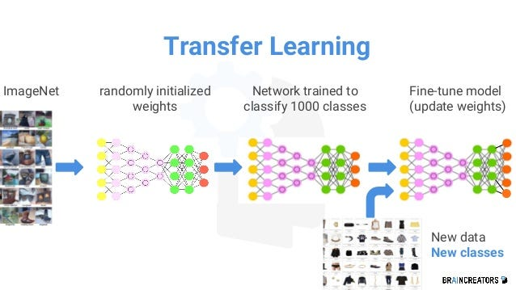

Fig 5.1: Transfer Learning

**5.1.1 Key Concepts of Transfer Learning**

**Pre-trained Model**: A model that has already been trained on a large dataset for a similar task. In transfer learning, the knowledge that the pre-trained model has acquired is transferred to the new task.

In the proposed system, the VGG19 model is pre-trained on **ImageNet**, a large-scale dataset containing millions of images across a wide variety of categories. The model has learned to recognize general features in images, such as edges, textures, and patterns, which are not task-specific but can be beneficial for other image classification tasks.

**Fine-Tuning**: The process of modifying and training the later layers of the pre-trained model on the new task while keeping the earlier layers frozen (i.e., their weights remain unchanged).

In the case of pneumonia detection, fine-tuning the VGG19 model involves training the deeper layers of the model with a dataset of chest X-ray images, allowing the model to adjust and learn specific features related to pneumonia.

**Feature Reusability**: The lower and mid-level layers of the pre-trained model (such as convolutional layers) capture basic image features like edges, textures, and simple patterns. These features are generally useful for most image recognition tasks, which is why they are "reused" in transfer learning.

In this case, the VGG19 model’s lower layers, trained on the vast ImageNet dataset, can effectively detect general image features (edges, shapes, textures), which are useful for detecting abnormalities like pneumonia in X-ray images.

**New Task Adaptation**: Transfer learning allows the model to adapt to the new task with minimal adjustments. The transfer of knowledge from the pre-trained model to the new model helps it generalize better, even with a smaller dataset for the new task.

For pneumonia detection, while the VGG19 model may have been originally trained for a classification task such as distinguishing between a wide variety of objects (e.g., dogs, cats, cars), the fine-tuning process will adjust the model to classify chest X-ray images as either "Pneumonia" or "Normal."

**5.1.2 Steps Involved in Transfer Learning**

1. **Select Pre-trained Model**: The first step is to choose a pre-trained model that has been trained on a sufficiently large dataset. For the pneumonia detection system, **VGG19** is selected due to its deep architecture and success in image classification tasks.VGG19 is known for its depth and ability to capture hierarchical features from images, making it suitable for medical image analysis like chest X-ray classification.
2. **Freeze Early Layers**: The initial convolutional layers of the pre-trained model, which capture general visual features such as edges and textures, are typically frozen during fine-tuning. Freezing these layers means their weights will not be updated during training on the new dataset, saving computational resources and preventing overfitting. For pneumonia detection, these early layers are not modified since they already have learned valuable features that are broadly applicable across many images.
3. **Replace and Train the Top Layers**: The top (fully connected) layers of the pre-trained model are replaced with a smaller architecture suitable for the new task. These layers are then trained on the task-specific dataset. In the proposed system, the fully connected layers are replaced with a binary classification head that determines whether the image depicts "Pneumonia" or "Normal."
4. **Fine-tune the Model**: The later layers (which are more specific to the task) are unfrozen, and the model is retrained using the smaller, task-specific dataset. Fine-tuning adjusts the model to better handle the specific features of the new data. This step allows the model to specialize in recognizing the subtle differences between normal chest X-rays and those showing signs of pneumonia, without needing a large dataset from scratch.

**5.1.3 Benefits of Transfer Learning in Pneumonia Detection**

1. **Efficiency with Limited Data**: Transfer learning is particularly beneficial when labeled data for the new task is scarce. Medical datasets like chest X-rays are often difficult to acquire in large quantities, but transfer learning enables the model to achieve high performance even with a small set of labeled medical images. By leveraging the general image features learned from ImageNet, the system can apply these learned features to classify chest X-rays without the need for an extensive dataset of pneumonia images.
2. **Improved Performance**: Since the VGG19 model has already been trained on millions of images, it has learned a variety of general features that can be effectively applied to new tasks. Fine-tuning these features for pneumonia detection ensures that the model is better at detecting even the most subtle signs of pneumonia in X-rays. The deep structure of VGG19, after fine-tuning, helps the model capture complex visual features that are crucial for accurate pneumonia detection.
3. **Reduced Computational Resources**: Training a deep model like VGG19 from scratch requires significant computational power and time. Transfer learning reduces this burden by allowing the model to start with pre-trained weights, thus reducing the amount of training required and the computational cost. This makes the pneumonia detection system more feasible for deployment in medical environments where computational resources might be limited.
4. **Faster Convergence**: With transfer learning, the model can converge to a solution much faster than training from scratch because the weights in the early layers of the model are already well-optimized. The model requires fewer epochs to reach a high level of accuracy on the pneumonia

detection task. Fine-tuning VGG19 on the chest X-ray dataset will enable the model to adjust and perform well more quickly than if it were starting from random weights.

Transfer learning plays a pivotal role in the proposed pneumonia detection system, offering a way to efficiently adapt pre-trained deep learning models to a new task with limited labeled data. By leveraging VGG19's learned features from a large, diverse dataset like ImageNet, the model can quickly learn to recognize patterns in chest X-ray images, enabling accurate and efficient pneumonia detection with reduced computational resources and training time.

**5.2 VGG19 MODEL:**

**5.2.1 VGG19:**

**VGG19** is a deep Convolutional Neural Network (CNN) model developed by the **Visual Geometry Group (VGG)** at the **University of Oxford**. It was introduced as part of the research for the **ImageNet Large Scale Visual Recognition Challenge (ILSVRC) 2014**, where it achieved outstanding performance in image classification tasks. VGG19 is known for its simplicity, effectiveness, and structured architecture, making it one of the most popular deep learning models for image recognition, especially in applications such as medical imaging, including pneumonia detection in chest X-ray images.

The architecture of VGG19 is designed to process images by progressively learning more complex features through a deep sequence of convolutional layers. The model uses small **3x3 convolutional filters** and **2x2 max-pooling layers**, resulting in a deep and computationally efficient architecture. The simplicity and uniformity of its structure are key factors in its widespread adoption in various image classification tasks.

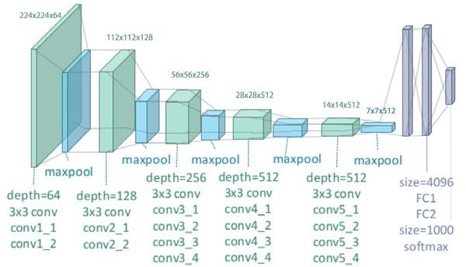

Fig 5.2: Architecture of Proposed System : VGG 19

**VGG19 Model Overview**

VGG19 consists of **19 layers**, where the layers are primarily composed of:

* **Convolutional layers** (to extract features from the image)
* **ReLU activation functions** (to introduce non-linearity)
* **Max-pooling layers** (to reduce the spatial dimensions of the image while retaining essential features)
* **Fully connected layers** (to perform the final classification or decision-making)

The model's architecture is relatively deep compared to earlier CNN models, which allows it to capture hierarchical features at different levels of abstraction from the input image.

**5.2.2 Model Architecture:**

**1. Input Size**: The input to the VGG19 model is a fixed-size image of **224x224 pixels** with **3 color channels (RGB)**. This means each image is resized to fit the model’s required input size, where each pixel contains information for three color channels (Red, Green, and Blue). **224x224**: The image size is standard for most CNN models, ensuring it is large enough to contain sufficient spatial information yet manageable in terms of computational requirements.

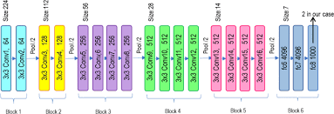

Fig 5.3: Block based structure of VGG19 MODEL

**2. Block 1: Layers**:

* **Convolutional Layers**: The first block consists of **2 convolutional layers**. Each layer uses **64 filters** with a filter size of **3x3**. These filters are used to extract local features from the image, such as edges, corners, and basic textures.
* **ReLU Activation**: After each convolutional layer, a **ReLU (Rectified Linear Unit)** activation function is applied to introduce non-linearity, enabling the model to learn more complex patterns.
* **Max-Pooling Layer**: After the convolutional layers, a **2x2 max-pooling** layer is applied to downsample the output feature map. This reduces the spatial dimensions of the feature maps, helping reduce the computational complexity and making the model more efficient. Max-pooling retains only the most important features from each region.
* **Purpose**: The purpose of this block is to detect low-level features in the image, such as edges and simple textures. These low-level features are the building blocks for higher-level features in deeper layers.

**3. Block 2: Layers**:

* **2 Convolutional Layers**: The second block has **2 convolutional layers** with **128 filters** (3x3 filters). These layers build on the features extracted in the previous block and start capturing more complex patterns.
* **ReLU Activation**: Each convolutional layer is followed by a **ReLU activation** to increase the model's non-linearity and enable it to capture more intricate patterns.
* **Max-Pooling Layer**: As in Block 1, a **2x2 max-pooling** layer follows the convolutional layers to reduce the feature map’s spatial dimensions.
* **Purpose**: In this block, the network starts detecting more complex patterns like edges and textures that represent parts of objects or shapes.

**4. Block 3: Layers**:

* **4 Convolutional Layers**: This block consists of **4 convolutional layers**, each with **256 filters** (3x3 filters). These deeper layers allow the network to start learning more abstract and complex features from the input image.
* **ReLU Activation**: The convolutional layers are followed by **ReLU activations**, allowing the network to capture non-linear patterns.
* **Max-Pooling Layer**: A **2x2 max-pooling** layer is applied after the convolutional layers to downsample the feature maps and reduce their spatial dimensions.
* **Purpose**: Block 3 is responsible for learning more advanced features, such as shapes or parts of objects. The number of filters is increased to **256** to capture increasingly complex patterns as the layers deepen.

**5. Block 4: Layers**:

* **4 Convolutional Layers**: This block also consists of **4 convolutional layers**, each using **512 filters** (3x3 filters). The increased number of filters allows the model to learn even more complex features from the image data.
* **ReLU Activation**: Each convolutional layer is followed by a **ReLU activation** to enhance the network's ability to learn non-linear relationships in the data.
* **Max-Pooling Layer**: A **2x2 max-pooling** layer is applied after the convolutional layers to reduce spatial resolution and retain the most important features.
* **Purpose**: Block 4 captures high-level features, such as complex textures, object parts, or patterns that represent larger components of the image.

**6. Block 5: Layers**:

* **4 Convolutional Layers**: The final convolutional block in the VGG19 model consists of **4 convolutional layers**, each with **512 filters** (3x3 filters). The use of **512 filters** allows the model to capture the most complex features in the data, such as intricate patterns and fine details.
* **ReLU Activation**: As in previous blocks, **ReLU activation functions** are used to introduce non-linearity and allow the model to capture more complex patterns.
* **Max-Pooling Layer**: A **2x2 max-pooling** layer is applied at the end of the block, reducing the spatial size of the feature maps.
* **Purpose**: Block 5 helps the model learn the most detailed and abstract representations of the image, allowing it to detect subtle abnormalities that are crucial for tasks like pneumonia detection.

**7. Fully Connected (FC) Layers:**

* **First Fully Connected Layer**: After the convolutional and pooling layers, the feature maps are flattened into a **1D vector**. This vector is passed through the first fully connected (FC) layer with **4096 neurons**.
* **Second Fully Connected Layer**: The output from the first FC layer is passed to the second fully connected layer, also with **4096 neurons**.
* **Third Fully Connected Layer (Output Layer)**: The final FC layer has as many neurons as there are output classes. For binary classification (e.g., pneumonia vs. normal), this layer would have **2 neurons**, one for each class.
* **Purpose**: The fully connected layers are responsible for interpreting the features extracted by the convolutional layers and making the final classification decision based on those features. These layers combine the extracted high-level features into a final output, determining which class the image belongs to (e.g., pneumonia or normal).

**8. Output Layer:**

* **Activation Function**: The final output layer uses the **Softmax activation function**, which converts the raw output of the fully connected layer into a probability distribution across the classes.
* **Purpose**: In the case of pneumonia detection, the softmax function would output two values representing the likelihood of the input image belonging to either the **pneumonia** or **normal** class. The class with the highest probability is selected as the model's prediction.

**Key Characteristics of VGG19 Architecture:**

* **Small Convolution Filters (3x3)**: The use of 3x3 filters throughout the model ensures that the network can learn small features, which are combined at deeper layers to capture increasingly complex patterns.
* **Deep Structure**: VGG19 consists of 19 layers, allowing it to capture hierarchical features at different levels of abstraction.
* **Pooling Layers**: Max-pooling layers are used to downsample the feature maps, which reduces computational complexity and helps make the model more robust to small translations in the image.
* **Fully Connected Layers**: The fully connected layers at the end of the network perform the classification task by interpreting the features extracted by the convolutional layers.

**CHAPTER - 6**

**SYSTEM IMPLEMENTATION**

**CHAPTER – 6**

**SYSTEM IMPLEMENTATION**

**6.1 Data Preprocessing:**

**6.1.1 Data**

The dataset utilized in this project comprises chest X-ray images, meticulously categorized into two distinct classes: *Pneumonia* and *Normal*. This dataset has become a cornerstone resource in the field of medical imaging research, contributing significantly to the development of automated disease detection systems. Publicly accessible through renowned platforms such as **Kaggle** and the **National Institutes of Health (NIH) Clinical Center**, the dataset encompasses thousands of high-quality X-ray images, particularly from pediatric patients, providing a rich foundation for training deep learning models.

For the effective implementation of this system, the dataset is methodically partitioned into three subsets, each serving a unique purpose. The **training set** forms the largest portion, allowing the model to learn and adapt its internal parameters by observing a wide variety of cases. Following this, the **validation set** plays a crucial role in fine-tuning the model by providing feedback during the training phase, helping to adjust hyperparameters and prevent overfitting. Finally, the **test set** remains unseen during the model’s learning process and is reserved exclusively for the final evaluation, offering an unbiased assessment of the model’s predictive performance on new, unseen data.

**6.1.2 Preparing the Data for Model Training**

Before the chest X-ray images can be utilized for training the deep learning model, they must undergo a series of preprocessing steps designed to optimize the data for effective learning. The first critical step involves **resizing** every image to dimensions of **224x224 pixels**, ensuring uniformity across the dataset and compatibility with the input size expected by the **VGG19** model architecture. Standardizing the image dimensions not only streamlines the training process but also helps the model better focus on identifying disease-relevant features.

Following resizing, each image undergoes **normalization**, a process that scales pixel intensity values to a range between 0 and 1. This step is essential, as it stabilizes the training process by preventing large input values from overwhelming the model's computations. By normalizing the data, the model can learn more efficiently, leading to faster convergence and improved performance.

To further enhance the robustness and generalization ability of the model, **data augmentation** techniques are applied, particularly to the training set. These techniques artificially expand the dataset by introducing realistic variations such as image rotations, horizontal and vertical flipping, zooming in and out, and shifting along the X and Y axes. By exposing the model to a diverse set of augmented images, it becomes better equipped to handle variations in real-world data, thereby reducing the risk of overfitting and improving predictive accuracy on unseen images.

Finally, the dataset is carefully split to support the training process. Approximately **80% of the data is allocated for training**, enabling the model to learn from a broad and varied set of examples. The remaining **20% is set aside for validation**, providing ongoing feedback during training to fine-tune the model’s parameters and optimize performance. A completely separate **test set** is maintained for final evaluation, ensuring that the model's accuracy and reliability are assessed on data that has not influenced the training in any way.

**6.2 Model**

The core of this pneumonia detection system is built upon a deep learning model that combines the strengths of **transfer learning** with the powerful architecture of **VGG19**. By leveraging the capabilities of a pre-trained model, the system gains a significant advantage in terms of performance and efficiency, especially when working with limited medical datasets. The model is carefully structured to extract rich features from chest X-ray images and accurately classify them into *Normal* or *Pneumonia* categories. Each component of the model is purposefully selected to enhance learning and improve generalization on unseen data.

**6.2.1 Transfer Learning with VGG19**

In this system, the widely acclaimed **VGG19** model is employed through the technique of **transfer learning**. Originally trained on the large and diverse **ImageNet** dataset, which contains millions of labeled images from thousands of categories, the VGG19 model possesses deep feature extraction capabilities that are transferable to new tasks. By fine-tuning this pre-trained model on chest X-ray images specific to pneumonia detection, the system benefits from the model's prior knowledge of visual patterns, such as edges, textures, and shapes. This process significantly boosts performance, even though the medical dataset is relatively smaller in comparison to ImageNet.

Transfer learning allows the system to converge faster during training and reduces the computational resources required, while maintaining high levels of accuracy. It essentially bridges the gap between general visual knowledge learned from natural images and the domain-specific knowledge required for medical imaging.

**6.2.2 Model Layers**

The model architecture is carefully composed of several layers, each contributing uniquely to the system’s classification capabilities. At its foundation lie the **VGG19 base layers**, consisting of deep convolutional layers that have been pre-trained on the ImageNet dataset. These layers are initially **frozen** during the initial phase of training to preserve the valuable patterns and features learned from large-scale image recognition. By using these base layers as powerful **feature extractors**, the system effectively captures intricate visual cues from chest X-rays.

Following the base layers, a **Global Average Pooling** layer is incorporated, which reduces the spatial dimensions of the feature maps without losing essential information. This operation helps condense the rich feature maps into a more manageable form while preserving their representational power, thereby reducing the risk of overfitting and improving model generalization.

On top of this, **Dense layers** (fully connected layers) are added to perform the final classification task. These layers are responsible for mapping the extracted features to the target classes. To enhance robustness and prevent overfitting, **dropout layers** are included within the dense layer stack, randomly deactivating a fraction of neurons during training and encouraging the model to learn more generalizable patterns.

The architecture concludes with an **Output Layer**, which contains **2 neurons** representing the two target classes: *Normal* and *Pneumonia*. A **softmax activation** function is applied at this stage to convert the raw output scores into normalized probability values, enabling the model to make confident predictions about the class of each input image.

**6.2.3 Activation Function – ReLU**

Throughout the model, the **Rectified Linear Unit (ReLU)** activation function is employed in both the convolutional and dense layers. ReLU plays a vital role by introducing **non-linearity** into the network, allowing it to learn and model complex patterns within the data. It operates by outputting zero for any negative input and retaining the positive input as-is. This simple yet powerful mechanism enables faster training by mitigating issues like vanishing gradients and ensures that the model can capture the intricate variations present in medical images.

**6.2.4 Loss Function – Binary Cross Entropy**

We know that the classification task involves distinguishing between two classes—*Normal* and *Pneumonia*—the model utilizes **Binary Cross Entropy** as its loss function. This loss function is specifically designed for binary classification problems and measures the difference between the true labels and the predicted probability distributions generated by the model. During training, Binary Cross Entropy guides the learning process by penalizing incorrect predictions and encouraging the model to improve its accuracy with each iteration. It effectively ensures that the system converges towards optimal classification performance.

**CHAPTER-7**

**WORKFLOW OF THE SYSTEM**

**CHAPTER – 7**

**WORKFLOW OF THE SYSTEM**

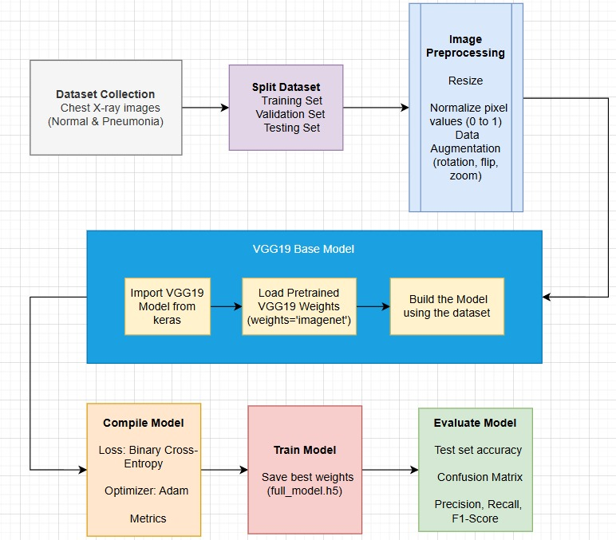

Fig 7.1 : Workflow of the System

**7.1 Dataset Collection**

The dataset used in this system consists of chest X-ray images that are categorized into two classes: **Normal** and **Pneumonia**. These images are collected from publicly available medical repositories, such as Kaggle and the NIH Clinical Center. The dataset primarily contains pediatric chest X-ray images that have been labeled by medical professionals, ensuring the reliability and accuracy of the annotations.  
The collected dataset forms the backbone of this project, as it provides real-world medical imaging data that is used to train and evaluate the deep learning model. The diversity in the images, including variations in patient age, X-ray quality, and pneumonia severity, helps the system to learn generalized patterns for accurate classification.

**7.2 Dataset Splitting**

To build a robust and effective model, the collected dataset is split into three distinct parts: the **Training Set**, the **Validation Set**, and the **Testing Set**.

* The **Training Set** is used to train the deep learning model. It allows the model to learn from the input images and adjust its internal weights to minimize prediction errors.
* The **Validation Set** is utilized during the training phase to fine-tune the model’s hyperparameters and monitor its performance on unseen data. This helps in preventing overfitting and ensures that the model generalizes well.
* The **Testing Set** is reserved for the final evaluation of the model. It provides an unbiased assessment of the model's real-world performance after training is complete.

In this system, the dataset is typically split in such a way that around **80%** of the data is used for training, while the remaining **20%** is divided between validation and testing. This structured splitting ensures that the model is trained effectively and evaluated fairly on unseen data.

**7.3 Image Preprocessing**

Before training the model, the raw chest X-ray images undergo several preprocessing steps to ensure they are in a suitable format for deep learning and to enhance the performance of the model. Preprocessing is a critical step that improves the model's accuracy, training stability, and generalization capabilities.

**Image Resizing**

All images in the dataset are resized to a uniform dimension of **224x224 pixels**. This size matches the input shape expected by the **VGG19** model, which was originally trained on images of this resolution. Resizing ensures consistency across the dataset, allowing the model to process the images efficiently.

**Normalization of Pixel Values**

To improve the training process, the pixel values of the images are normalized. Each pixel value, originally ranging from 0 to 255, is scaled down to a range between **0 and 1** by dividing by 255. Normalization helps in stabilizing and accelerating the training process by ensuring that the input data has a consistent scale, making it easier for the model to learn patterns.

**Data Augmentation**

To increase the diversity of the training data and reduce the risk of overfitting, **data augmentation techniques** are applied to the training images. These techniques artificially generate new images by making random but realistic transformations, such as:

* **Rotation**: Slightly rotating the image to simulate different angles.
* **Flipping**: Horizontally flipping the image to introduce variability.
* **Zooming**: Randomly zooming into portions of the image.
* **Shifting**: Translating the image along the width or height.

Data augmentation not only increases the effective size of the dataset but also helps the model become more robust to variations and improves its ability to generalize on unseen data.

**Dataset Splitting and Pipeline Integration**

After preprocessing, the dataset is split into **Training**, **Validation**, and **Testing** sets as described earlier. The preprocessing pipeline is integrated into the data loading process so that every image fed into the model during training and evaluation passes through these steps. This ensures uniformity and consistency throughout the model development lifecycle.

Overall, image preprocessing serves as the foundation for preparing high-quality, standardized input that maximizes the learning potential of the VGG19 model in this pneumonia detection system.

**7.4 Model Preparation using VGG19**

In this section, we prepare the **VGG19** model to be fine-tuned for our pneumonia detection task. VGG19 is a deep convolutional neural network that has been widely used in image classification tasks due to its simplicity and effectiveness. It is a 19-layer network pre-trained on the **ImageNet** dataset, which contains millions of labeled images across thousands of categories.

**Importing VGG19 Model from Keras**

To begin with, we import the **VGG19** model from Keras, a deep learning library that provides access to several popular architectures, including VGG19. Keras offers an easy-to-use API for loading pre-trained models, which simplifies the process of leveraging transfer learning. The pre-trained VGG19 model comes with all the necessary layers, making it ready for customization.

from keras.applications.vgg19 import VGG19

This import statement allows us to access the VGG19 model in Keras and utilize its structure, pretrained weights, and other utilities provided by the library.

**Loading Pretrained Weights (weights='imagenet')**

The VGG19 model can be initialized with pre-trained weights from **ImageNet**, a large-scale visual recognition database that contains over a million images categorized into 1,000 classes. By loading the **ImageNet** weights, we take advantage of the model's previously learned features, such as edge detection, textures, and object recognition. This significantly accelerates the learning process for our specific task, as the model already has a foundational understanding of low-level and mid-level features that are common across various types of images.

model = VGG19(weights='imagenet', include_top=False, input_shape=(224, 224, 3))

In this step:

* **weights='imagenet'** specifies that the VGG19 model should use the pre-trained weights learned from ImageNet. These weights will allow the model to perform general image recognition tasks without requiring training from scratch.
* **include_top=False** is used to exclude the fully connected classification layers at the top of the model. This is essential because we will be adding our own custom layers suited to the pneumonia detection task, where the number of classes is different from the 1,000 classes used in ImageNet.
* **input_shape=(224, 224, 3)** defines the shape of the input images, where each image is resized to 224x224 pixels with 3 color channels (RGB). This ensures that the input is compatible with the VGG19 model.

**Building the Model**

Once the VGG19 model is loaded with pre-trained weights, we proceed to customize the network for our specific classification problem. The VGG19 model will serve as the feature extraction backbone, and we will append new layers on top to perform the final classification.

This process involves:

1. **Flattening the output** from the convolutional layers of VGG19 to prepare it for the fully connected layers.
2. **Adding fully connected layers** to learn higher-level representations relevant to pneumonia detection.
3. **Using dropout layers** to reduce overfitting by randomly disabling a fraction of the neurons during training.

The new custom layers are then connected to the VGG19 base model, resulting in a final model that can be trained on the chest X-ray dataset for pneumonia detection.

**7.5 Model Compilation**

After preparing the model, the next step is **model compilation**, which involves configuring the model with the following:

**Loss Function: Binary Cross-Entropy**

The **loss function** is used to quantify how well or poorly the model's predictions align with the actual data labels. For binary classification tasks like pneumonia detection (where there are two classes: Normal and Pneumonia), **binary cross-entropy** is the most suitable choice.

* **Binary Cross-Entropy** calculates the difference between the predicted probabilities and the true binary labels (0 or 1). The function measures how far off the predicted probabilities are from the true class labels. The goal during training is to minimize this loss function, improving the model's predictions.
* This loss function works by calculating the log loss for each sample and then averaging it across the dataset. A lower loss indicates that the model is making predictions closer to the actual labels.

It is especially suitable for cases where we are trying to predict the probability of one class versus another (for example, "normal" vs. "pneumonia" based on X-ray images).

**Optimizer: Adam**

The **optimizer** determines how the model's weights are updated during training. Among various optimizers, **Adam (Adaptive Moment Estimation)** is widely used due to its efficiency and effectiveness.

* Adam combines the advantages of two other popular optimizers: **Adagrad** (which adapts learning rates to different features) and **RMSProp** (which keeps a moving average of the squared gradients to avoid oscillations).
* Adam maintains two moving averages (of the gradients and the squared gradients) to adjust the learning rates dynamically for each parameter. This helps the model converge faster, with less effort in hyperparameter tuning.
* Adam is robust to noisy data and sparse gradients, making it a popular choice for deep learning tasks.

**7.6 Model Training**

Once the model is compiled, the next step is **model training**, where the model learns from the training data and updates its weights to minimize the loss function.

**Training the Model**

During **training**, the model is provided with the training data, which consists of the chest X-ray images and their corresponding labels (normal or pneumonia). The training data is typically divided into **batches**, and the model updates its weights after processing each batch. This process is repeated over multiple **epochs** (iterations through the entire dataset).

* **Epochs** represent how many times the model will iterate over the entire training dataset. In each epoch, the model performs forward and backward passes, adjusts the weights, and calculates the loss and metrics.
* **Batch Size** determines how many samples are processed before updating the model’s weights. A larger batch size may improve training stability, but it requires more memory and may result in slower updates.
* **Training Data and Validation Data**: The model learns from the training data and is evaluated on the validation data at the end of each epoch to track its progress.

During training, the model tries to learn the patterns and features from the chest X-ray images that distinguish pneumonia from normal cases. The training process stops when the specified number of epochs is completed or when early stopping criteria (such as the model’s performance on the validation set) are met.

**Saving Best Weights (full_model.h5)**

To prevent overfitting and to ensure that the best-performing model is saved, the weights of the model are saved at the end of each epoch, especially if the model improves on the validation set.

* **Model Checkpoints**: By saving the weights of the model after each epoch (especially if the validation loss is improved), we ensure that we always have the best model available.
* **Saving Weights**: The saved model (typically saved as full_model.h5) contains the weights of the neural network that are best suited for making predictions. This is particularly useful for deployment, as you can load the saved weights and make predictions without having to retrain the model.

The saved model weights can also be loaded later for fine-tuning or for resuming training.

**7.7 Model Evaluation**

After training, the model is evaluated to assess its performance on unseen data (i.e., the test set). This step provides insight into how well the model generalizes to new, unseen images.

**Testing Model Accuracy**

Once the model has been trained, its performance is tested on a separate **test dataset** that it has not seen before. This step helps ensure that the model has not simply memorized the training data (overfitting) and that it can generalize well to new data.

* The **accuracy** on the test set is reported as a measure of the model's overall performance.
* **Test Accuracy** gives an understanding of how often the model correctly classifies images as either "normal" or "pneumonia" when evaluated on the test set.

**Generating Confusion Matrix**

The **confusion matrix** is a valuable tool for evaluating classification performance, especially in binary classification tasks. It summarizes the prediction results in a matrix format, showing the counts of:

* **True Positives (TP)**: Correctly predicted pneumonia images.
* **True Negatives (TN)**: Correctly predicted normal images.
* **False Positives (FP)**: Normal images incorrectly predicted as pneumonia.
* **False Negatives (FN)**: Pneumonia images incorrectly predicted as normal.

The confusion matrix provides detailed insight into how the model is making its predictions, and can help identify which classes are being confused with each other.

**Evaluation Metrics**

Once the model is compiled, **evaluation metrics** provide insight into how well the model performs. For classification tasks, **accuracy** is commonly used, but there are other metrics to consider, especially when dealing with imbalanced datasets.

* **Accuracy** measures the percentage of correct predictions out of all predictions. While it's a good general metric, it might not be sufficient for imbalanced classes (e.g., if one class is much more frequent than the other).
* **Precision**, **Recall**, and **F1-Score** provide a more detailed performance evaluation, especially in cases of class imbalance.

In the context of pneumonia detection:

* **Accuracy** tells us how often the model correctly identifies both classes (normal and pneumonia).
* **Precision** measures the proportion of true positive predictions out of all positive predictions made (i.e., how many of the predicted pneumonia cases were actually pneumonia).
* **Recall** tells us how many of the actual pneumonia cases were correctly predicted by the model.
* **F1-Score** balances precision and recall, providing a single metric that considers both false positives and false negatives.

**Calculating Precision, Recall, F1-Score**

The **precision**, **recall**, and **F1-score** are additional metrics calculated from the confusion matrix to evaluate the performance of the model more thoroughly:

* **Precision**: Precision measures the proportion of positive predictions (pneumonia cases) that were actually correct. It is calculated as:

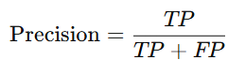

High precision means the model is making fewer false positive errors (predicting pneumonia when the patient is normal).

* **Recall**: Recall measures the proportion of actual positive cases (pneumonia cases) that were correctly identified by the model. It is calculated as:

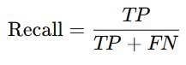

High recall means the model is identifying most of the pneumonia cases, even at the cost of some false positives.

* **F1-Score**: The F1-score is the harmonic mean of precision and recall, providing a balanced measure of both. It is particularly useful when the classes are imbalanced.

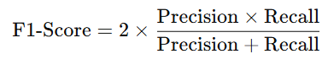

The F1-score ranges from 0 to 1, with a higher score indicating better performance.

**CHAPTER-8**

**SOURCE CODE**

**CHAPTER – 8**

**SOURCE CODE**

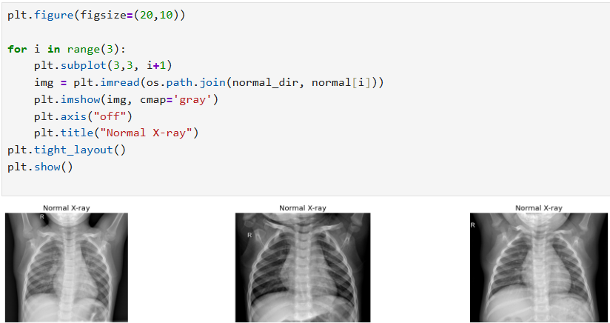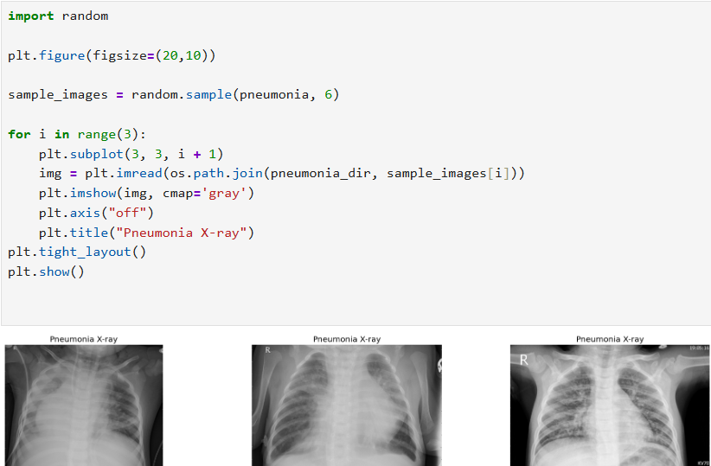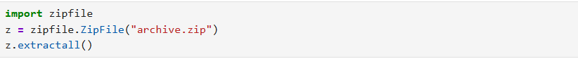**8.1 Dataset Loading and Visualization**

In this section, the dataset used for pneumonia detection is loaded into the project environment. The dataset consists of chest X-ray images categorized into two classes: *Pneumonia* and *Normal*. After loading, basic visualization techniques are applied to display sample images from each class. This helps in understanding the structure and quality of the data before proceeding with further processing and model training.

**8.2 Data Preprocessing and Augmentation**

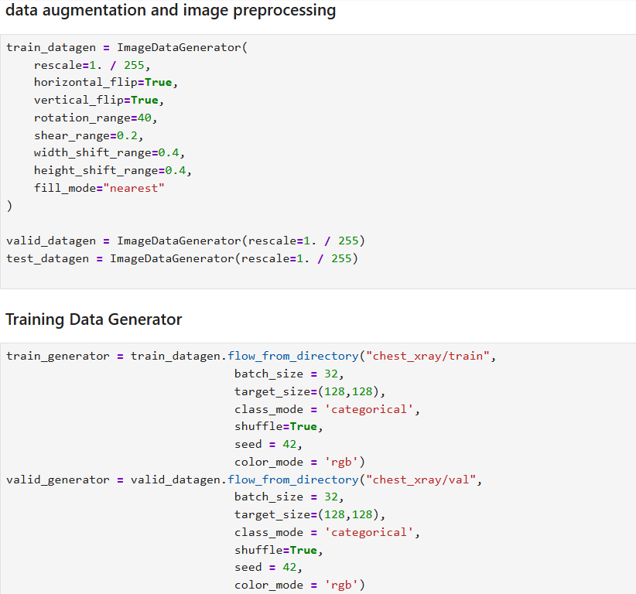

In this section, the loaded images are preprocessed to ensure they are in the correct format and size required for the deep learning model. Data augmentation techniques like rotation, flipping, and zooming are applied to increase the diversity of the training data. This helps improve the model's performance and reduces the risk of overfitting.

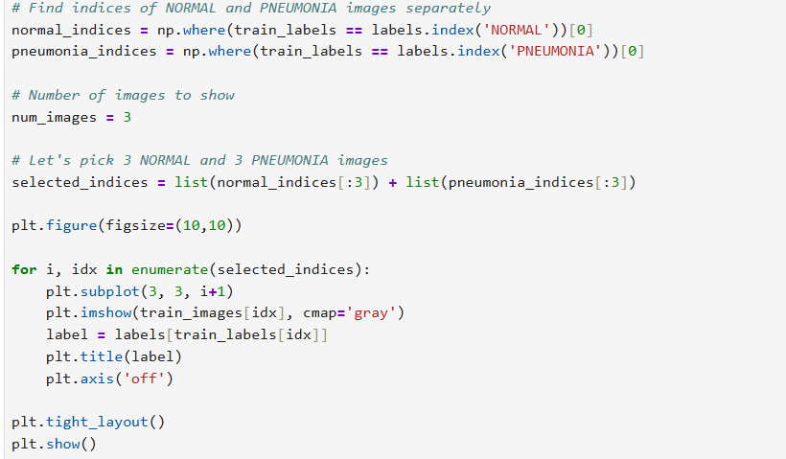

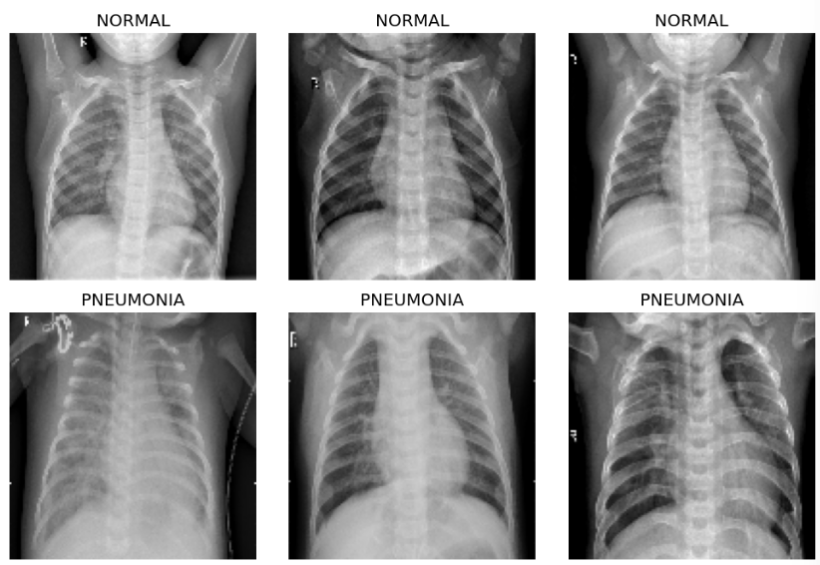

**8.3 Model Compilation and Training**

In this step, the VGG19 model is used as the base architecture with fine-tuning applied to adapt it for pneumonia detection. Additional layers are added to customize the model for our classification task. After defining the architecture, the model is compiled using an optimizer, loss function, and evaluation metrics. Finally, the model is trained on the prepared dataset to learn and improve its accuracy over multiple epochs.

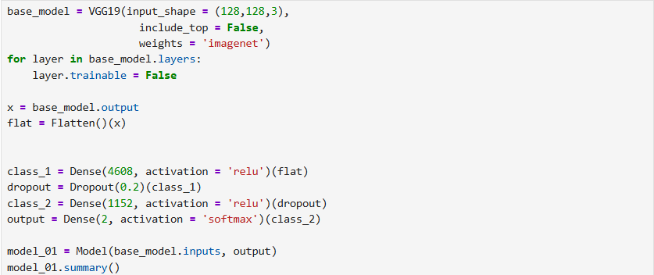

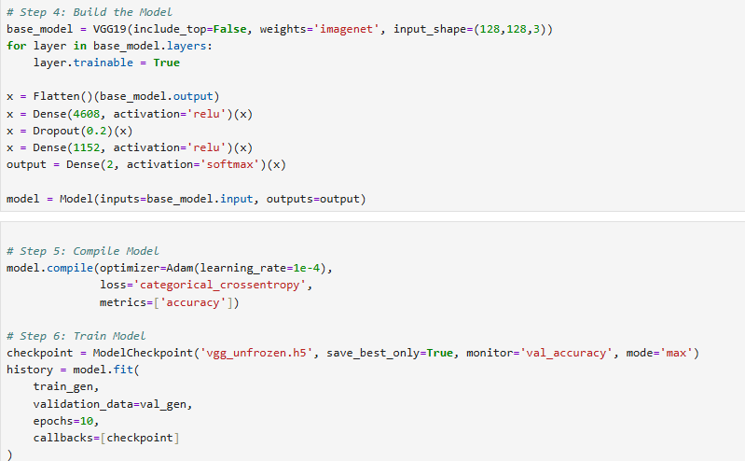

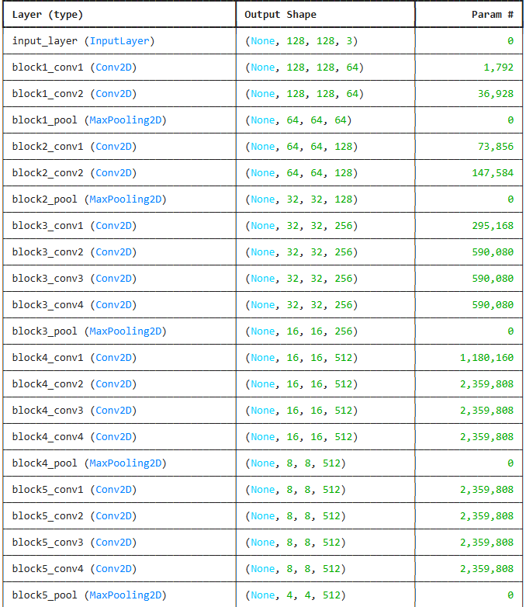

**8.4 Model Evaluation and Performance Metrics**

After training, the model is evaluated using test data to check its performance. Various metrics like accuracy, precision, recall, and F1-score are used to measure how well the model detects pneumonia. Confusion matrix and classification reports help in understanding the detailed performance of the model.

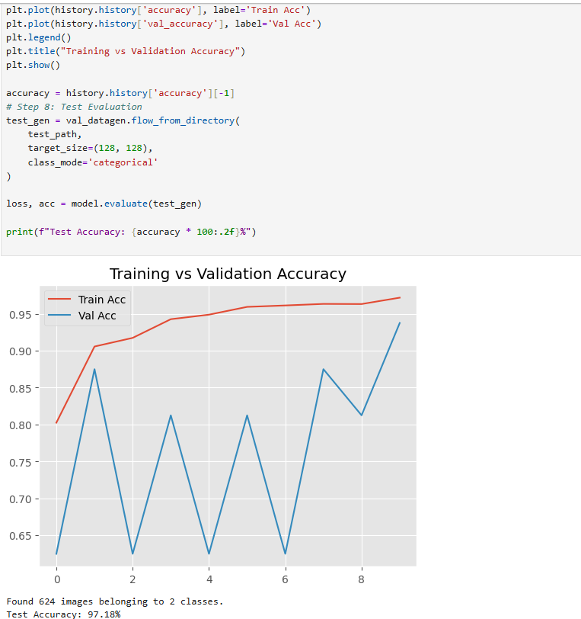

The graph shows the training and validation accuracy of a pneumonia detection model over 10 epochs. The red line represents the training accuracy, which consistently increases and reaches above 95%, showing that the model is learning well on the training data. The blue line represents the validation accuracy, which fluctuates across epochs but ends close to 94%, suggesting the model generalizes fairly well to unseen data.

Despite the fluctuations in validation accuracy, the final test accuracy is reported as 97.18%, indicating that the model performs very well on the test set. This high test accuracy, combined with stable and high training accuracy, suggests that the model has learned meaningful patterns and is capable of detecting pneumonia effectively from chest X-rays.

**8.5 Final Testing Results**

The confusion matrix is used to visualize the model’s performance by showing the number of correct and incorrect predictions for each class. Final testing results include overall accuracy and help confirm how effectively the model detects pneumonia in unseen data.

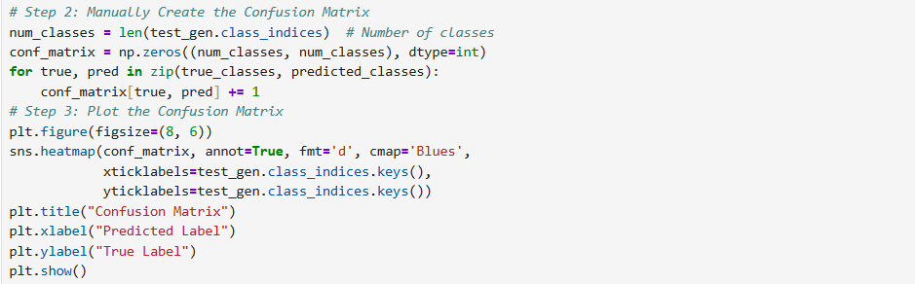

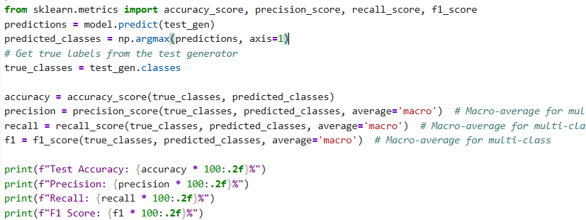

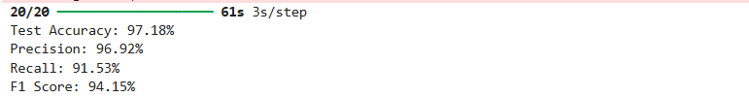

**CHAPTER-9**

**RESULTS AND**

**PERFORMANCE ANALYSIS**

**CHAPTER – 9**

**RESULTS AND PERFORMANCE ANALYSIS**

The evaluation of the pneumonia detection system was carried out using a labeled dataset of chest X-ray images, which included both normal and pneumonia cases. The model was assessed based on its ability to accurately classify these images into the correct categories. Various performance metrics such as accuracy, precision, recall, and F1-score were used to gauge the effectiveness of the model. These metrics help determine how well the system distinguishes between healthy and pneumonia-affected lungs.

To further enhance the reliability of the results, visual explanation techniques were employed using Grad-CAM, allowing for insight into the model’s decision-making process. The web interface built with Flask facilitated easy interaction, enabling users to upload images and receive real-time predictions along with interpretability features. The combined analysis of model performance and visual explanations supports the potential of this system as a valuable tool in medical diagnostics.

**9.1 Existing System**

The existing pneumonia detection system is based on a custom Convolutional Neural Network (CNN) designed from scratch. While this approach offers flexibility and simplicity, its performance is often limited by the depth and complexity of the architecture. With fewer layers and filters, the model may struggle to capture fine-grained patterns in chest X-ray images, especially in low-contrast or ambiguous cases. Additionally, training such models from scratch requires a larger labeled dataset and considerable computational effort. The lack of pre-trained weights also affects the generalization capability of the model when exposed to unseen data. As a result, the overall diagnostic accuracy, robustness, and reliability of the system remain constrained.

| **Metric** | **Value** |
| --- | --- |
| **Accuracy** | 92% |
| **Precision** | 90% |
| **Recall (Sensitivity)** | 87% |
| **F1 Score** | 89% |

**9.2 Proposed System**

To overcome the limitations of the custom CNN, the proposed system adopts a transfer learning approach using the VGG19 architecture. VGG19 is a deep and proven model pre-trained on the ImageNet dataset, making it capable of extracting high-level, abstract features from images. This significantly enhances the model’s ability to recognize subtle signs of pneumonia. Fine-tuning the VGG19 model on chest X-ray data improves accuracy even with a limited dataset. The proposed system also integrates Grad-CAM for visual interpretability, making predictions more transparent to clinicians. With a Flask-based web interface, the solution is user-friendly, scalable, and better suited for real-world clinical applications.

**9.2.1. Accuracy**

Accuracy is a metric used to evaluate the performance of a model in machine learning. It measures the percentage of correct predictions made by the model on the total number of predictions. In other words, accuracy indicates how well a model can classify data points into the correct categories. It is calculated by dividing the number of correct predictions by the total number of predictions and multiplying the result by 100 to get a percentage. Accuracy can be affected by various factors, such as the quality of the data, the complexity of the model, and the size of the dataset. A higher accuracy indicates that the model is performing better, while a lower accuracy suggests that the model needs improvement.

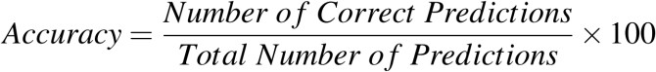

where the number of correct predictions refers to the number of instances that the model predicted the correct output and the total number of predictions is the total number of instances in the dataset that the model made predictions on. The accuracy is usually expressed as a percentage. The CNN model has achieved an accuracy of **97.18%** on the test data.

**9.2.2 Precision**

Precision is a metric used to evaluate the accuracy of a model’s positive predictions. It measures the percentage of true positive predictions out of all positive predictions made by the model. In other words, precision indicates how well a model can identify the correct positive class. It is calculated by dividing the number of true positive predictions by the total number of positive predictions. Precision is important in situations where the cost of false positives is high, such as in medical diagnosis or fraud 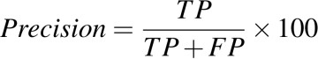detection. A higher precision indicates that the model is making fewer false positive errors.

where, TP refers to the True Positives and FP refers to the False Positives The CNN model has achieved a precision of **96.92%** on the test set.

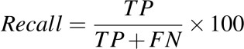**9.2.3 Recall**  
Recall is another metric used to evaluate the performance of a classification model. It measures the percentage of actual positive cases that are correctly identified by the model. In other words, recall tells us how many of the positive cases in the dataset were correctly identified as positive by the 55 model. It is calculated by dividing the number of true positives (TP) by the sum of true positives and false negatives (FN), and multiplying the result by 100 to get a percentage. A high recall indicates that the model is good at identifying positive cases, while a low recall suggests that the model may be missing some positive cases. The formula for recall is:

The CNN model has achieved a recall of **91.53%** on the test set.

**9.2.4 F1-score**

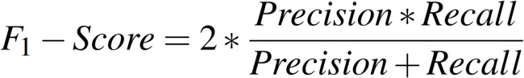F1-score is a metric used to evaluate the overall performance of a classification model. It is calculated based on the precision and recall of the model’s predictions. Precision is the proportion of true positive predictions out of all positive predictions, while recall is the proportion of true positive predictions out of all actual positives in the data. F1-score is the harmonic mean of precision and recall, which balances both metrics equally. It ranges from 0 to 1, with higher values indicating better performance.

The CNN model has achieved **94.15%** on F1 - score.

**9.3 Outputs of Web Interface**

**9.3.1 Home Page (User Interface)**

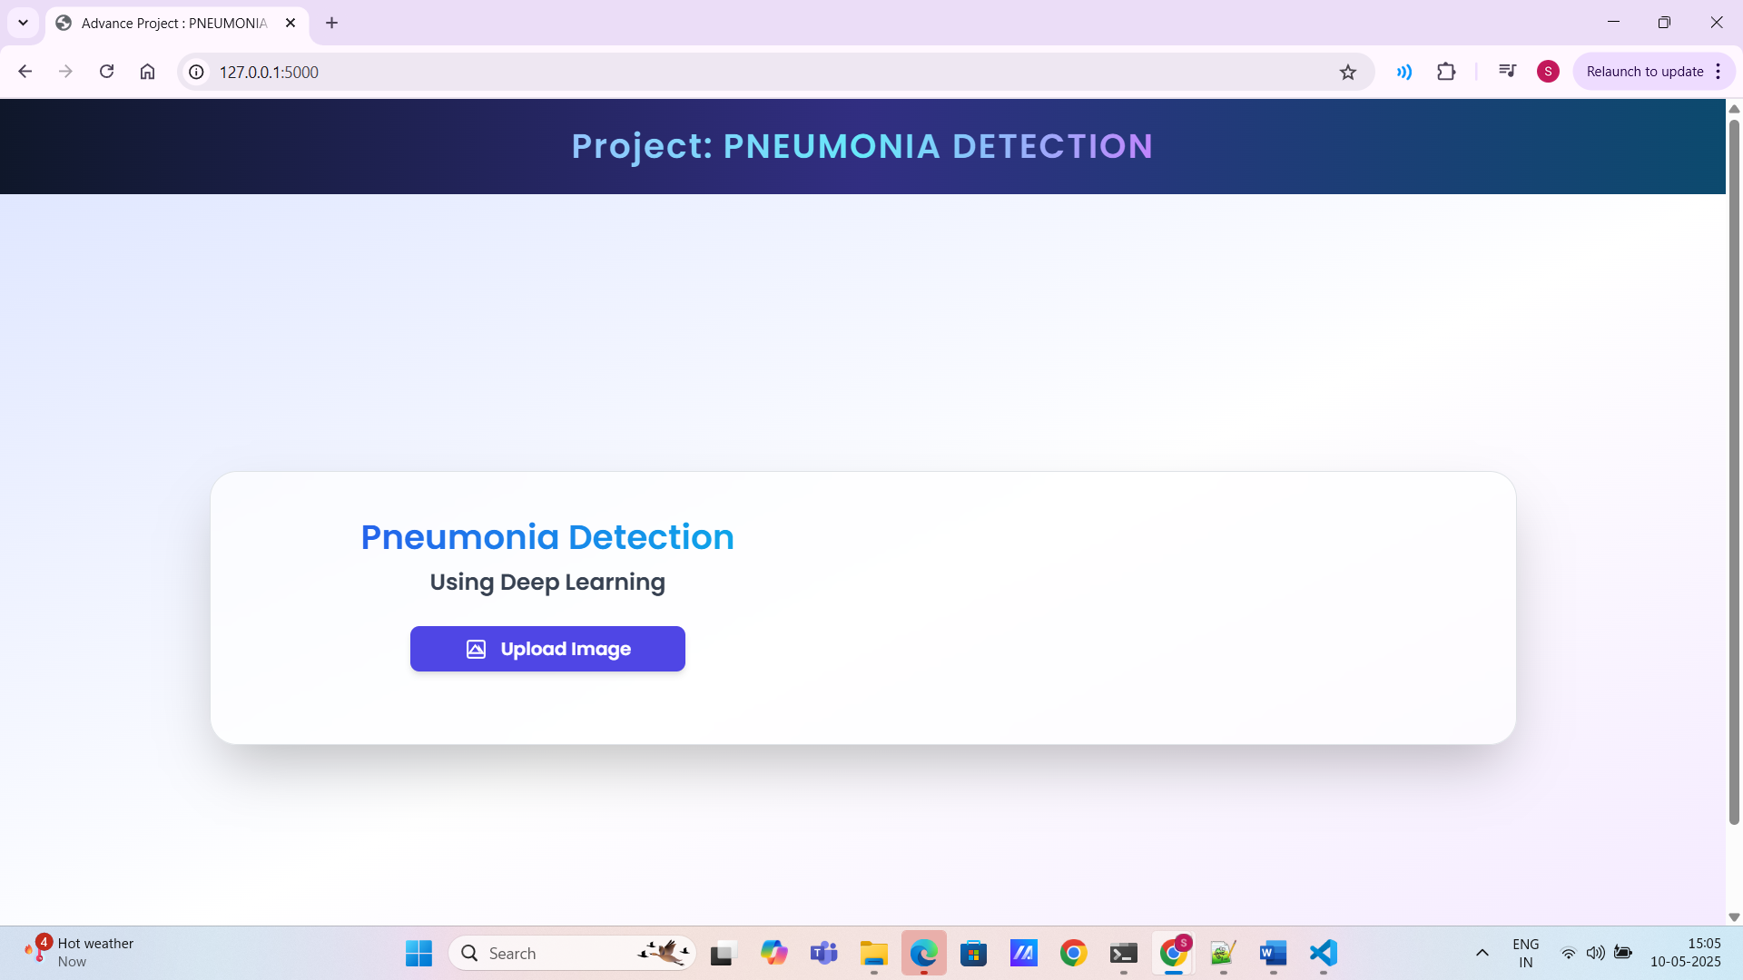The home page provides a clean and user-friendly interface where users can upload their chest X-ray images for analysis.  
**9.3.2 Chest X-ray Upload Interface**

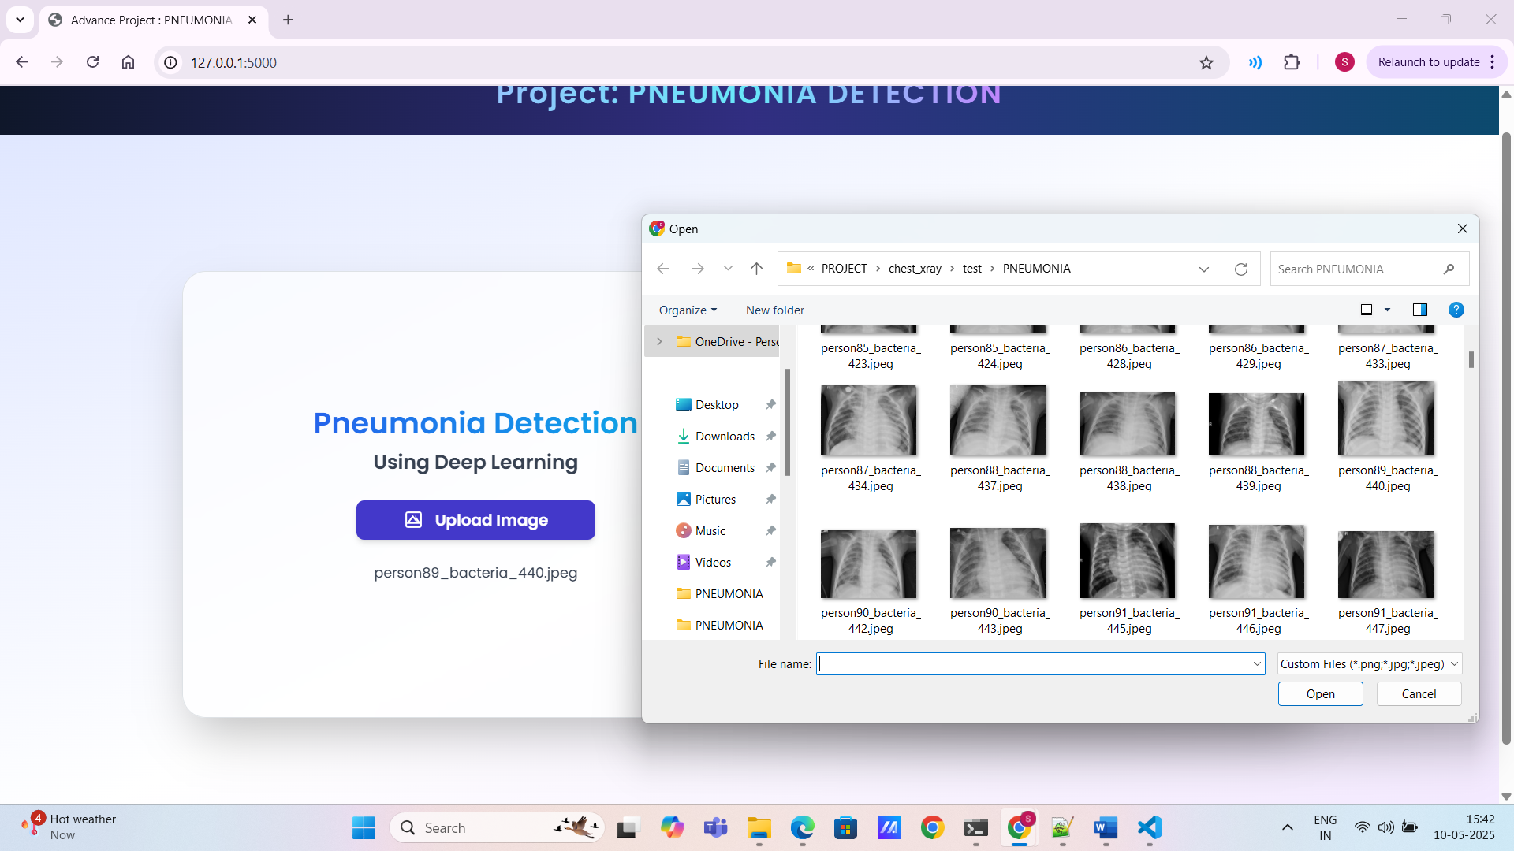

This section allows users to select and upload their chest X-ray images in supported formats for pneumonia detection.

**9.3.3 Preview of Uploaded Chest X-ray Image**

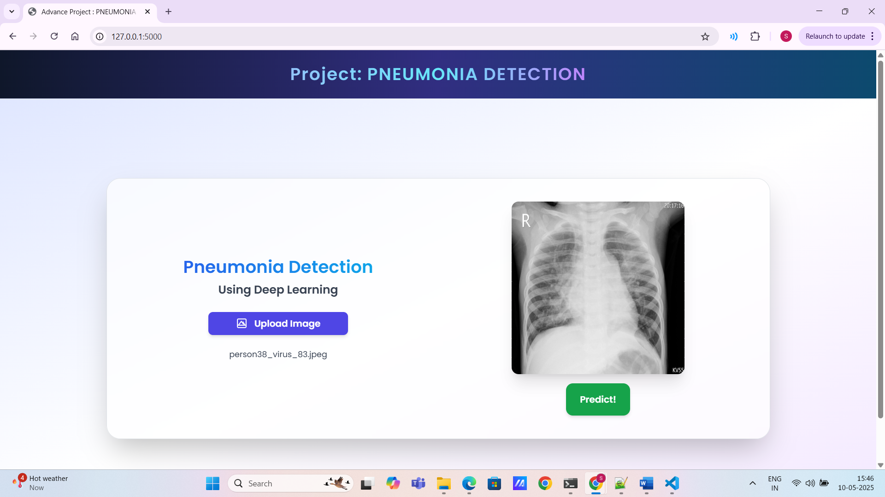Once an image is uploaded, the system displays a preview of the selected X-ray to confirm the correct file before processing.

**9.3.4 Pneumonia Detection Result Display**

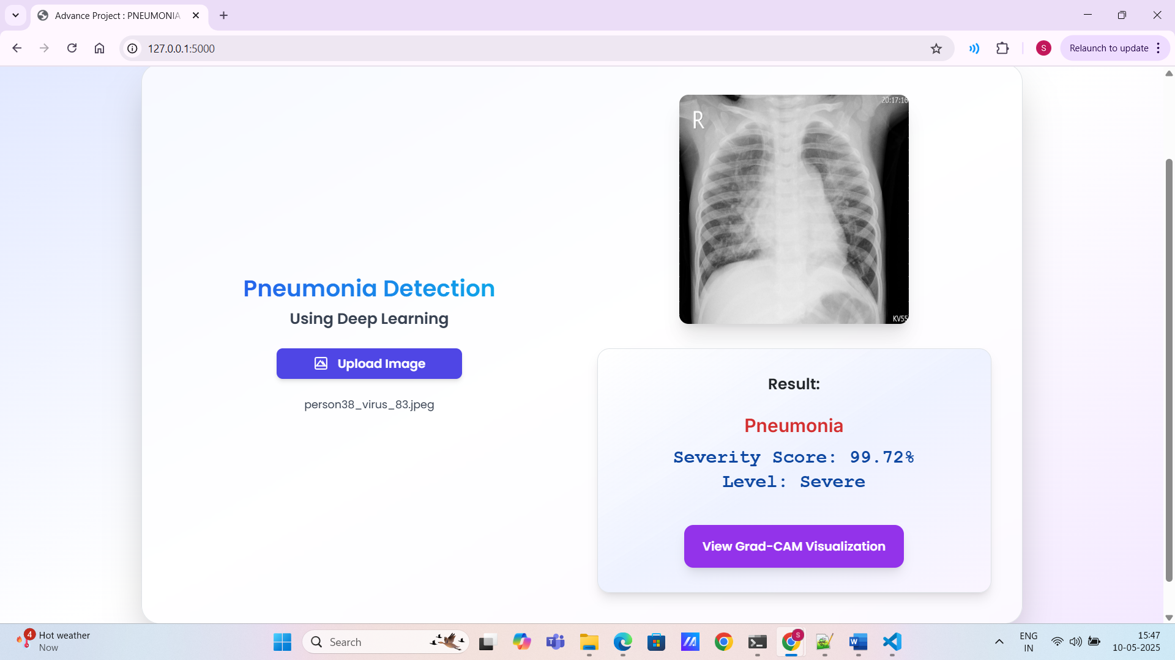

After analysing the image, the system displays the result indicating whether pneumonia is detected or not.

**9.3** **5 Enhanced Result Visualization with Grad-Cam Heatmap**

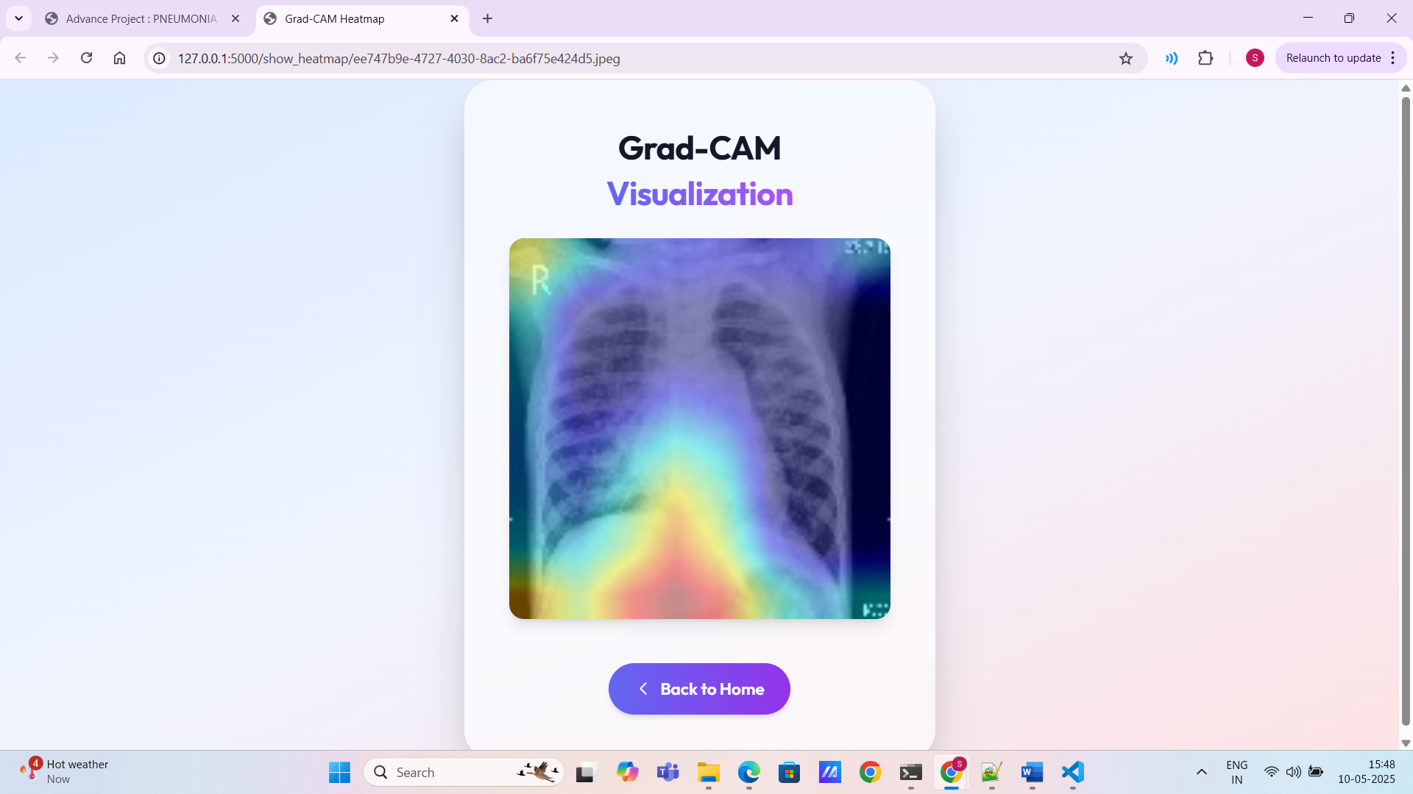

This feature provides a heatmap visualization (Grad-CAM) over the X-ray image, highlighting the regions that contributed to the model’s prediction.

**CHAPTER-10**

**CONCLUSION**

**AND**

**FUTURE SCOPE**

**CHAPTER-10**

**CONCLUSION AND FUTURE SCOPE**

**10.1 Conclusion**

The Pneumonia Detection project presented here demonstrates a robust and well-structured deep learning pipeline for the classification of chest X-ray images into "Normal" or "Pneumonia" categories. The dataset used is a labeled collection of real-world medical images, which undergoes essential preprocessing steps such as grayscale conversion, resizing, and normalization. This ensures the model receives clean and uniformly sized inputs.

The project implements a custom Convolutional Neural Network (CNN) architecture, trained from scratch using the processed dataset. The model is trained and evaluated using standard performance metrics such as accuracy, precision, recall, and F1-score, ensuring that the solution is not only accurate but also clinically meaningful. Data augmentation techniques are applied to make the model more generalizable and reduce overfitting, which is critical in medical imaging tasks.

A particularly commendable feature of the project is the integration of Grad-CAM (Gradient-weighted Class Activation Mapping). This technique is used to visualize which parts of the chest X-ray contributed most to the model’s prediction. By overlaying heatmaps on the original images, Grad-CAM offers a transparent and interpretable way to understand the model’s decision-making process—an important factor in healthcare applications where trust and explainability are paramount.

Furthermore, the entire pipeline is deployed in a practical setting using a Flask web application. This allows users to upload new X-ray images and receive immediate predictions, making the solution highly interactive and user-centric. The inclusion of this web interface bridges the gap between research and real-world usability, enabling the model to serve as a decision support tool for radiologists or healthcare workers, particularly in low-resource or rural areas.

In conclusion, this project successfully combines core deep learning techniques with practical application considerations to build an effective, interpretable, and deployable system for pneumonia detection. Its modular design and extensibility also make it a solid foundation for further enhancements in future medical AI systems.

**10.2 FUTURE SCOPE:**

The pneumonia detection system built using VGG19 and deep learning offers a solid foundation, but several enhancements can further improve its performance, usability, and clinical relevance. One promising direction is the integration of more advanced pre-trained models such as EfficientNet, ResNet, or Vision Transformers (ViTs), which may offer better accuracy, faster inference, and improved generalization on diverse datasets. Additionally, incorporating larger and more diverse X-ray datasets, including those from different demographic groups or varying disease stages, could enhance the model's robustness and reduce bias.

Integration with hospital management systems (HMS) and electronic health records (EHR) would allow seamless deployment in healthcare infrastructure, improving workflow and reducing manual errors. Another potential development is the use of active learning to let the system continuously improve as it receives more labeled data in clinical settings. To support clinical adoption, integrating explainability tools such as Grad-CAM, SHAP, or LIME can help doctors trust the model’s predictions. Finally, deploying the system in a cloud environment with patient data security protocols (e.g., HIPAA compliance) would make it more scalable and ready for real-world healthcare applications.

Another future improvement is the inclusion of multi-disease detection, allowing the system to diagnose not just pneumonia but also other chest-related conditions like tuberculosis or lung cancer. Furthermore, implementing real-time diagnostic features in mobile or embedded systems could extend the tool’s usability to remote and resource-limited areas. For broader impact, the model can be embedded in mobile applications or edge devices for offline detection in remote regions. In the long term, this approach can serve as a template for detecting other diseases through imaging, such as COVID-19, emphysema, or fibrosis, using similar architectures and frameworks.

**CHAPTER-11**

**REFERENCES**

**CHAPTER – 11**

**REFERENCES**

[1] Vandecia Fernandes et al., “Bayesian convolutional neural network estimation for pediatric pneumonia detection and diagnosis”, Computer Methods and Programs in Biomedicine, Elsevier, 2021

[2] Hongen Lu et al., “Transfer Learning from Pneumonia to COVID-19”, Asia-Pacific on Computer Science and Data Engineering (CSDE), 2020 IEEE

[3] Sammy V. Militante et al., “Pneumonia and COVID-19 Detection using Convolutional Neural Networks”, 2020 the third International on Vocational Education and Electrical Engineering (ICVEE), IEEE, 2021

[4] Nanette V. Dionisio et al., “Pneumonia Detection through Adaptive Deep Learning Models of Convolutional Neural Networks”, 2020 11th IEEE Control and System Graduate Research Colloquium (ICSGRC 2020), 8 August 2020

[5] Md. Jahid Hasan et al., “Deep Learning-based Detection and Segmentation of COVID-19 & Pneumonia on Chest X-ray Image”, 2021 International Information and Communication Technology for Sustainable Development (ICICT4SD), 27-28 February 2021

[6]https://www.kaggle.com/paultimothymooney/chest-xray-pneumonia

[7] LeCun, Y.; Boser, B.; Denker, J.S.; Henderson, D.; Howard, R.E.; Hubbard, W.; Jackel, L.D. Backpropagation applied to handwritten zip code recognition. Neural Comput. 1989, 1, 541–551.

[8] Krizhevsky, A.; Sutskever, I.; Hinton, G.E. Imagenet classification with deep convolutional neural networks. Adv. Neural Inf. Process. Syst. 2012, 25, 1097–1105.

[9] Simonyan, K.; Zisserman, A. Very deep convolutional networks for large-scale image recognition. arXiv 2014, arXiv:1409.1556

[10] R. R. Selvaraju, M. Cogswell, A. Das, R. Vedantam, D. Parikh and D. Batra, "Grad-CAM:

Visual Explanations from Deep Networks via Gradient-Based Localization," 2017 IEEE

International Conference on Computer Vision (ICCV), Venice, 2017, pp. 618-626.

[11] L. Wang and A. Wong, "COVID-Net: A tailored deep convolutional neural network design

for detection of COVID-19 cases from chest radiography images," arXiv:2003.09871, 2020.

[12] Kandula, Ashok Reddy, et al. ”ML Algorithms for Predictive Analysis in Identification of Chronic Liver Disease.” NeuroQuantology 20.15 (2022): 5951.

[13] M. Barstugan, U. Ozkaya, and S. Ozturk, “Coronavirus (covid-19) classification using ct images by machine learning methods,” 2020, arXiv:2003.09424.